**INVENT3D Printer Kit**

**Disassembly Instructions**

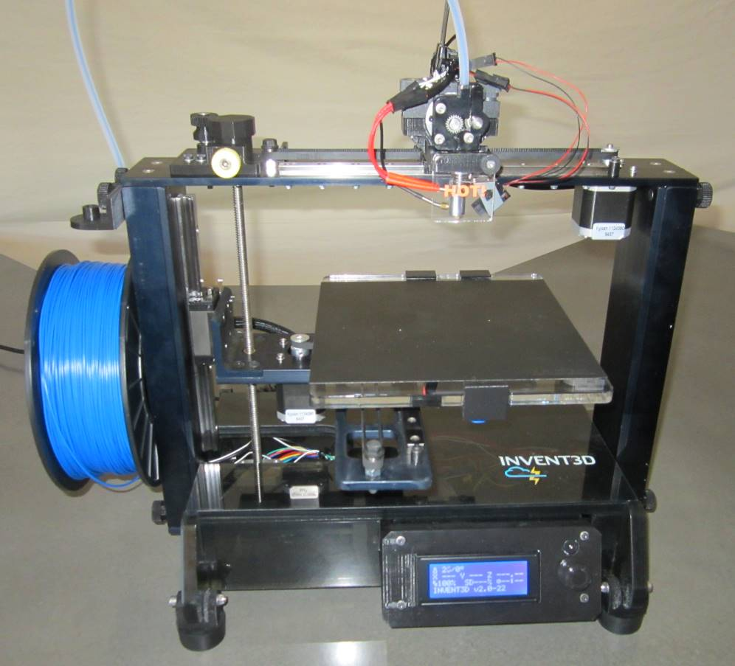

**DRAFT – REVISION 3**

**August 2, 2016**

**I. General Disassembly Instructions**

* Use the case layer drawings to ensure that components are stored in the appropriate location
* Use the appropriate size Allen wrench to loosen thumbscrews that are too tight to loosen by hand
* Unless otherwise noted, printer kit components and subassemblies are not to be disassembled; disassembly should return the printer kit to the same condition in which it arrived.
* Screws that are black anodized should not be removed.

**II. Case Layer Drawings**

The following Case Layer Drawings depict the layout and contents of each layer of components within the INVENT3D printer case. These drawings are labeled from the top down within the case, meaning Layer 1 is the top layer and Layer 4 is the bottom layer. Please review these drawings prior to disassembly and reference these drawings throughout the disassembly process to ensure that all components are stored in the appropriate locations.

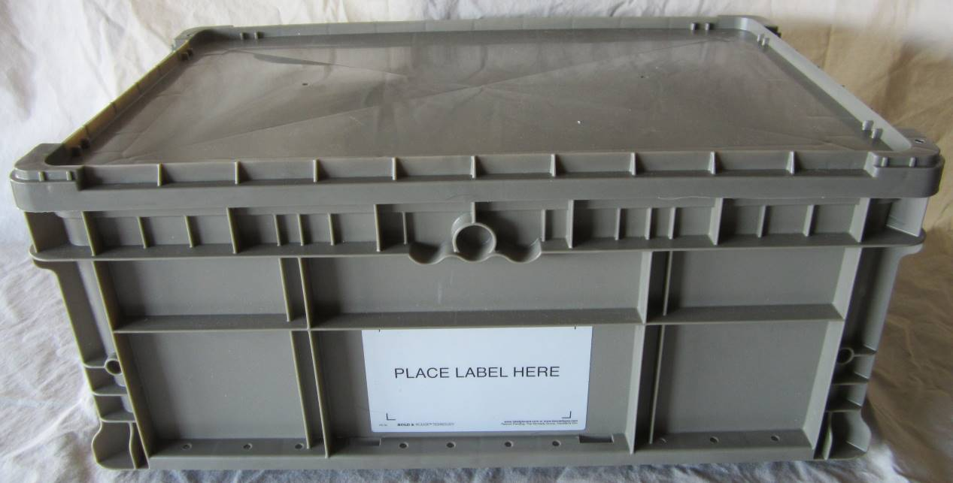

**Layer 4**

**Layer 3**

**Layer 2**

**Layer 1**

**Printer Kit Case**

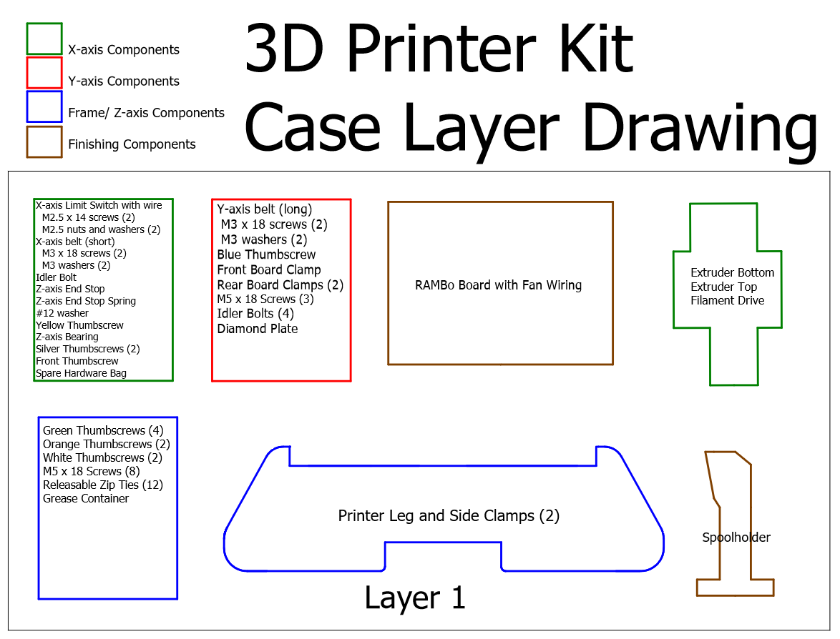

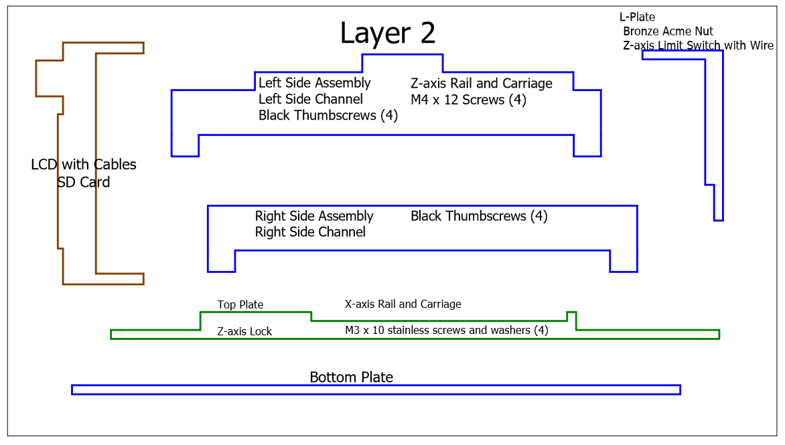

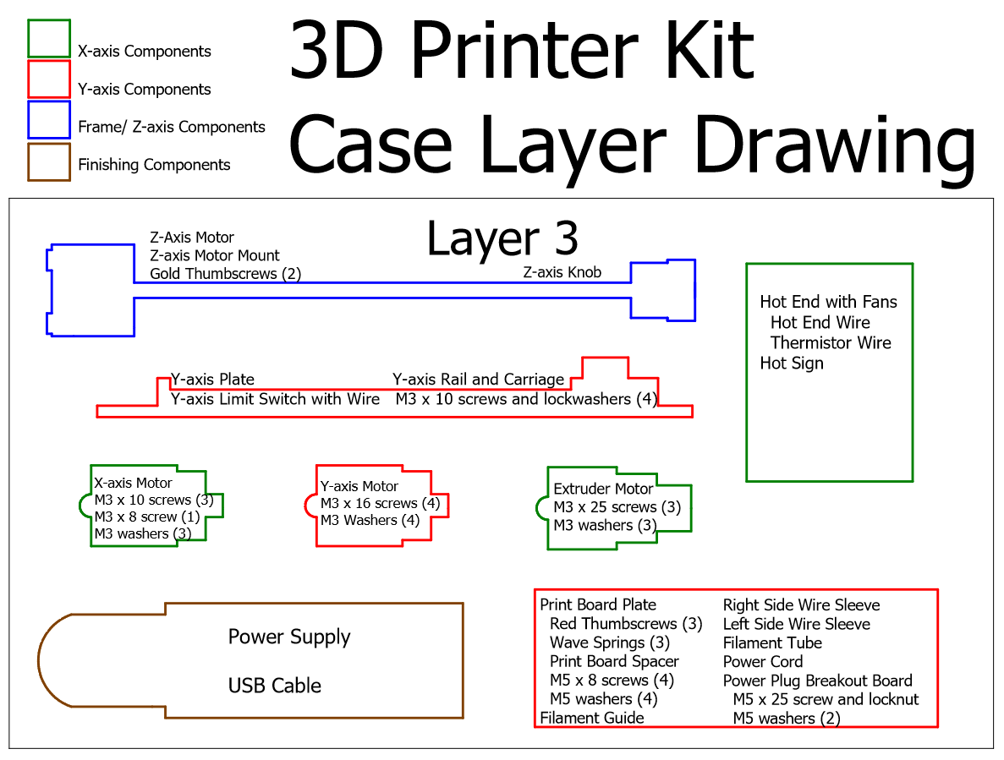

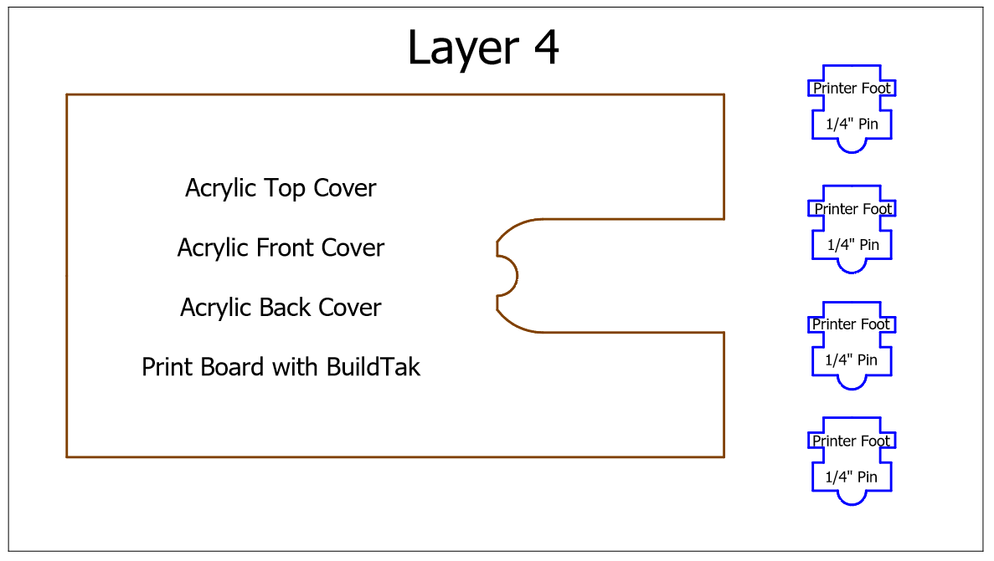

**III. Detailed Disassembly Instructions**

1. Back out filament. Refer to process for loading and unloading filament described in the INVENT3D Operating Instructions.
2. Place the filament tube and USB cable into location as shown in Case Layer Drawing 3.

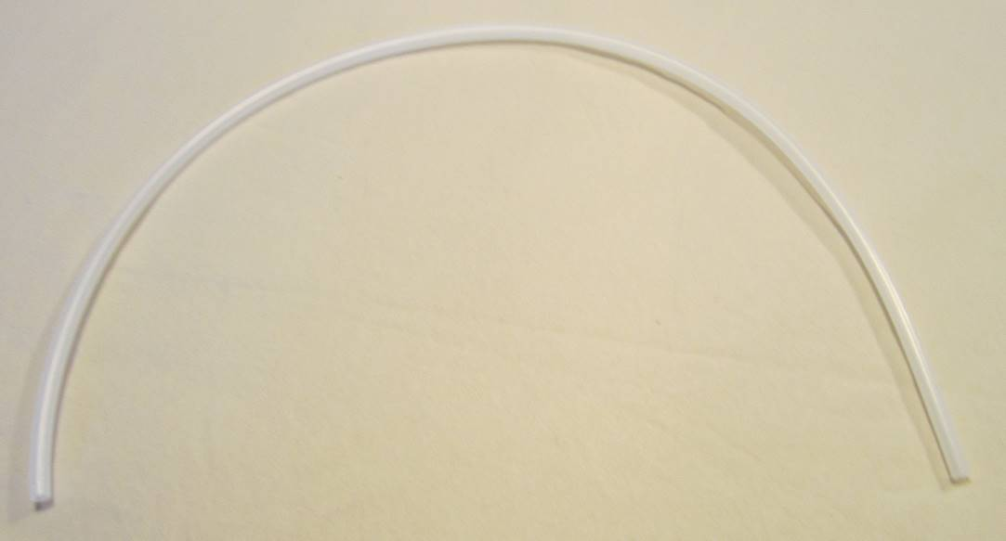

**Filament tube (Layer 3)**

1. Remove power supply and store in appropriate location as shown in Case Layer Drawing 3. The detachable cord can be stored when the second layer is placed on top.

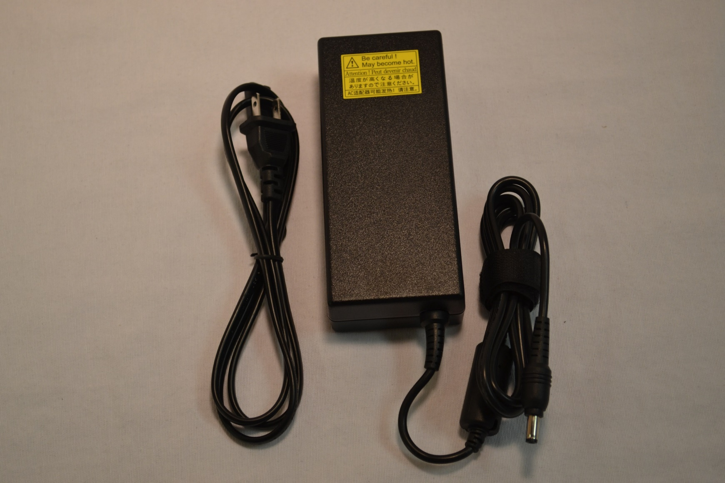

**Power supply (Layer 3)**

1. Remove side covers and eight black thumbscrews and set aside. Store filament guide in location as shown in Case Layer Drawing 3.

**Filament guide (Layer 3)**

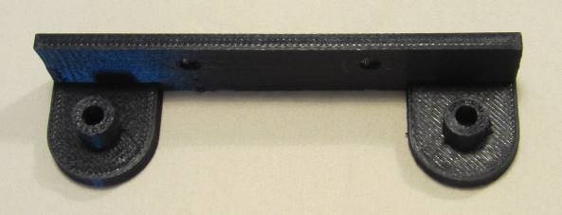

1. Remove white thumbscrews and spool holder from left side cover. Store spool holder in location as shown in Case Layer Drawing 1. Place white thumbscrews in z-axis and frame components box as shown in Case Layer Drawing 1.

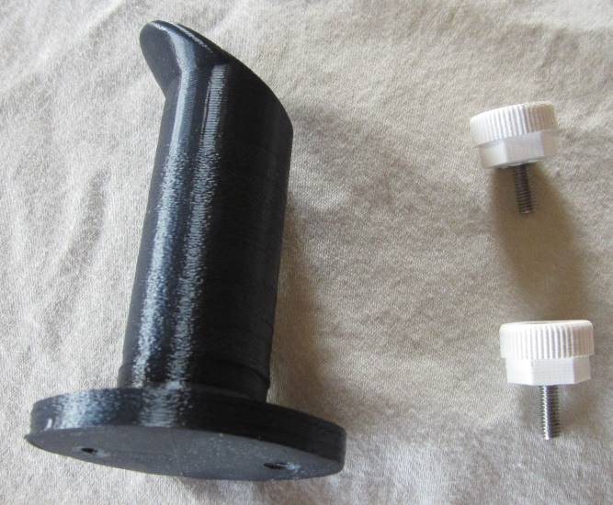

1. Remove top cover and store in location as shown in Case Layer Drawing 4.

**Top cover (Layer 4)**

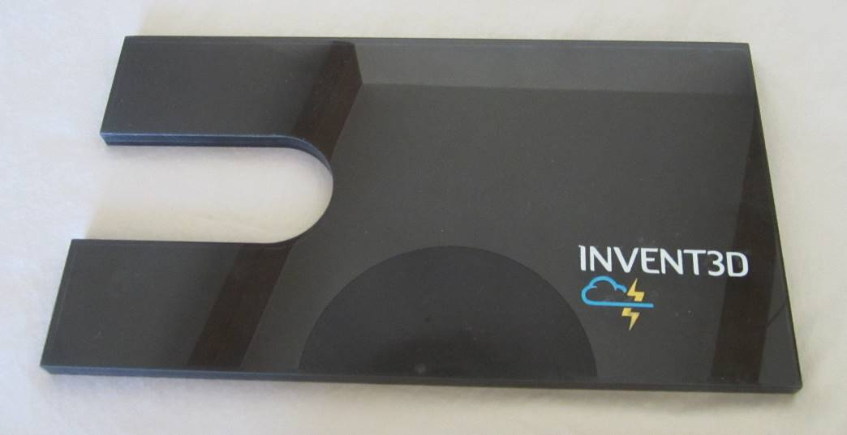

1. Remove all zip ties. Use needle nose pliers to assist in removing zip ties by placing pressure on the latch lightly with the pliers. Straighten the latch if bent after removing. Store zip ties in z-axis and frame components box as shown in Case Layer Drawing 1.

**Zip ties (Layer 1)**

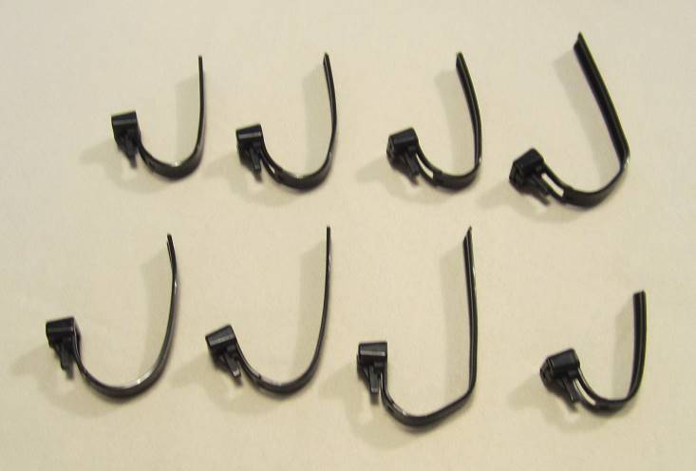

1. Remove wire sleeves. Place wire sleeves in location as shown in Case Layer Drawing 3.

**Wire sleeves (Layer 3)**

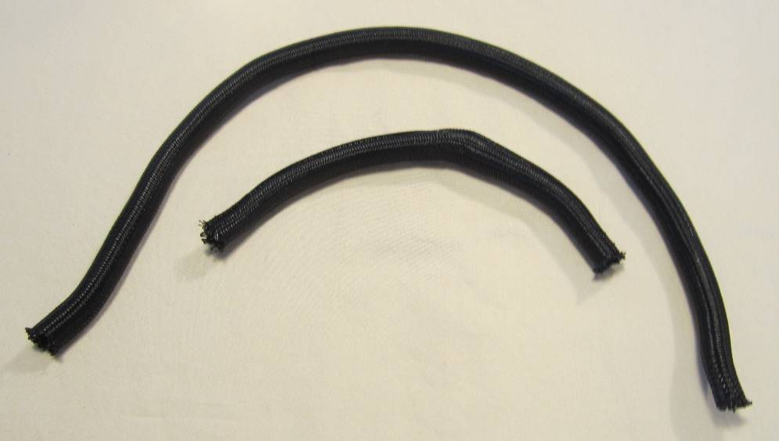

1. Remove print board. Store print board in location as shown in Case Layer Drawing 4.

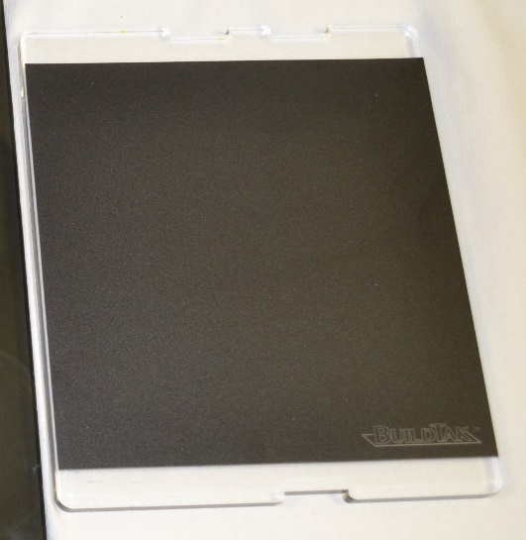

**Print board (Layer 4)**

1. Carefully remove all wiring from RAMBo board except for fan wiring. Be sure to depress latches for plugs that have latches – the plugs should be easy to remove with latches depressed.
2. Remove rear cover. Detach power plug breakout board from rear cover by removing set screw. Reattach set screw to power plug breakout board clip. Store rear cover in location as shown in Case Layer Drawing 4. Store power plug breakout board in location as shown in Case Layer Drawing 3.

**Rear cover (Layer 4) and power plug breakout board (Layer 3)**

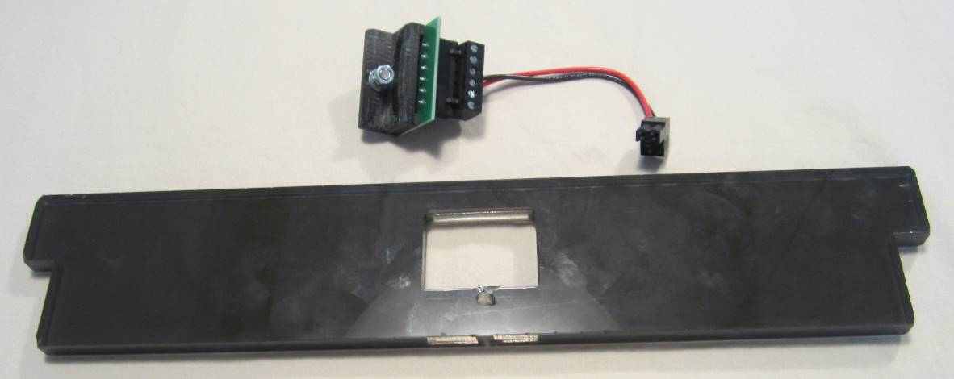

1. Remove black mini-thumbscrew and HOT! sign. Store the HOT! sign in plastic box for hot end components as shown in Case Layer Drawing 3. Store the black mini-thumbscrew in the plastic box for x-axis components as shown in Case Layer Drawing 1.

**HOT! sign (Layer 3) and black mini-thumbscrew (Layer 1)**

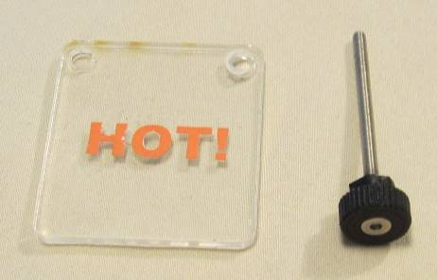

1. Disconnect fan wires from hot end. Remove all wires from circular cutouts in left and right frames. Remember that the fan wires stay attached to the RAMBo board.
2. Remove front cover with LCD screen. Remove the LCD screen from the front cover. Store the LCD screen in the location as shown in Case Layer Drawing 2. Place the front cover in the location as shown in Case Layer Drawing 4.

**Front cover (Layer 4)**

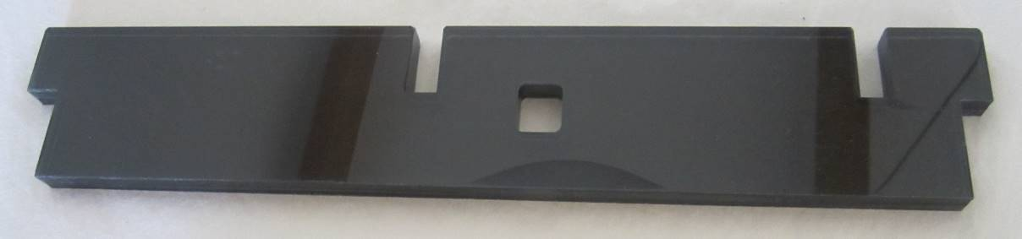

**LCD screen (Layer 2)**

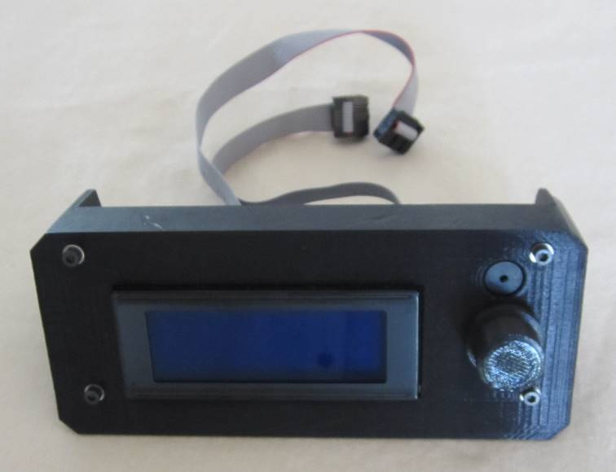

1. Remove orange thumbscrews and RAMBo board from bottom frame plate. Place the RAMBo board in the location as shown in Case Layer Drawing 1 with fan wiring coiled. Store the orange thumbscrews in the plastic case for z-axis and frame components as shown in Case Layer Drawing 1.

**RAMBo board and orange thumbscrews (Layer 1)**

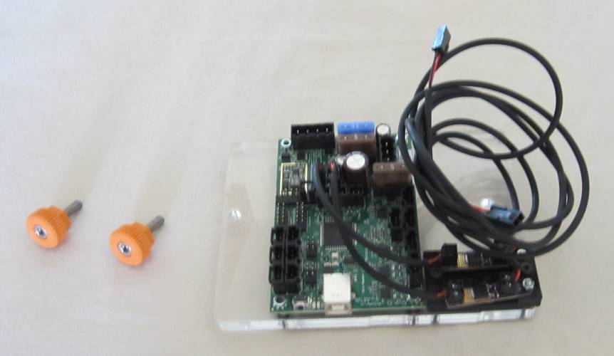

1. Remove silver thumbscrews and extruder top. Store the extruder top in the location as shown in Case Layer Drawing 1. Place the silver thumbscrews in the plastic box for x-axis components shown in Case Layer Drawing 1.

**Extruder top and silver thumbscrews (Layer 1)**

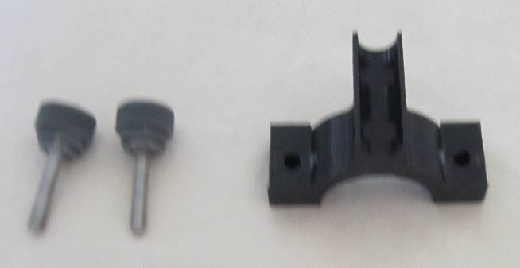

1. Remove the extruder motor from its seating on the extruder bottom. Remove the filament drive from the extruder motor and replace the filament drive mounting hardware in the extruder motor. Coil the extruder motor wire around the base of the motor and store in the location as shown in Case Layer Drawing 3. Store filament drive in location as shown in Case Layer Drawing 1.

**Extruder motor (Layer 3) and filament drive (Layer 1)**

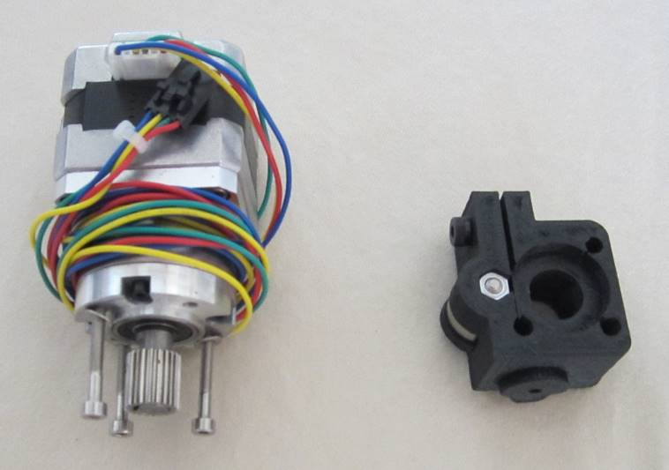

1. Carefully slide hot end along its slot on the extruder bottom to remove. Only apply pressure to the upper portion of the hot end. Coil wires and use a detachable zip tie to hold in place. Store the hot end in plastic box for hot end components as shown in Case Layer Drawing 3. Store hot end component box in location shown in Case Layer Drawing 1.

**Hot end (Layer 3)**

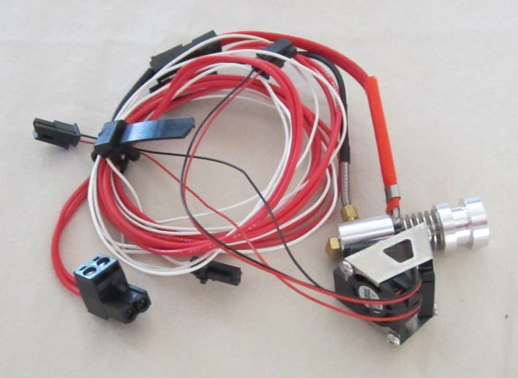

**Hot end components box ready for storage (Layer 3)**

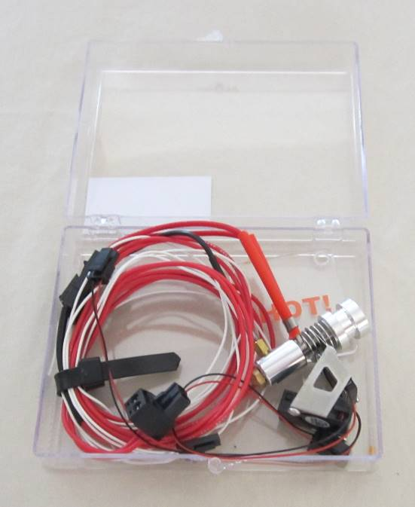

1. Remove the extruder bottom. Re-insert extruder bottom mounting hardware into the same locations they were removed on the x-axis rail carriage and x-axis belt clamp; longer screws should be inserted into the belt clamp. Remove x-axis limit switch from extruder bottom and re-insert the screws into the limit switch with nuts on ends. Coil limit switch wire and place in plastic box for x-axis components as shown in Case Layer Drawing 1. Store extruder bottom in location as shown in Case Layer Drawing 1; the extruder bottom should be placed below the extruder top and filament drive.

**X-axis limit switch (Layer 1)**

**Arrangement of extruder bottom, extruder top and filament drive within Layer 1**

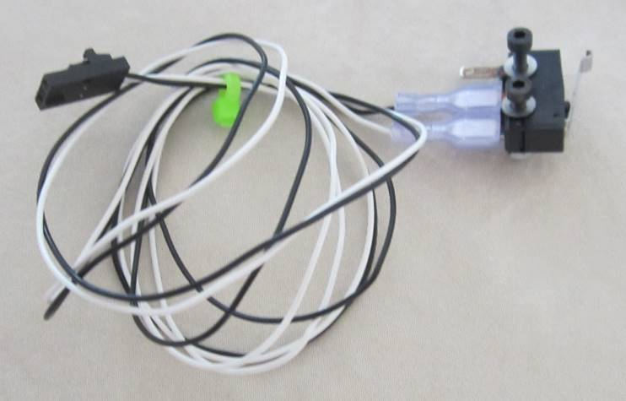

**Extruder bottom (Layer 1)**

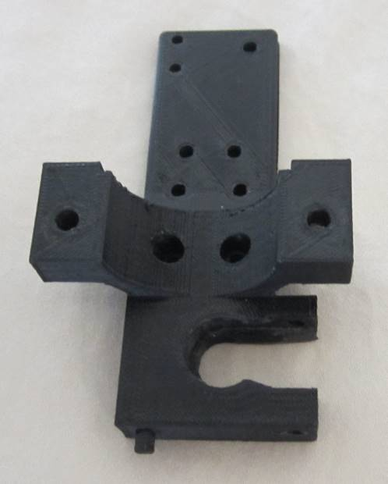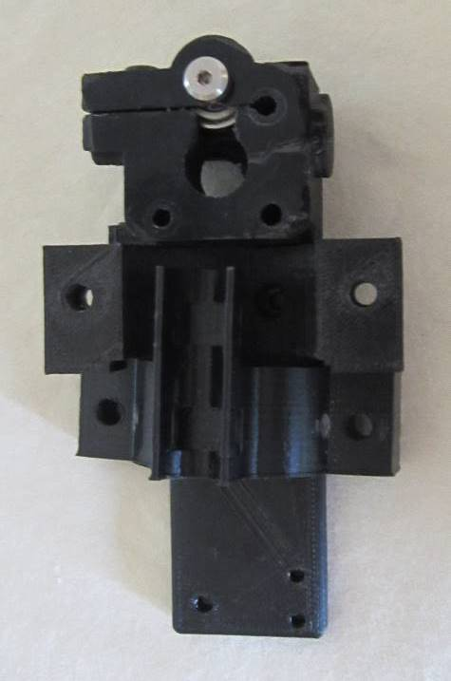

1. Remove idler bolt from top frame plate and re-attach nut to end. Remove x-axis belt. Remove z-axis limit switch end stop with spring. Remove yellow thumbscrew from z-axis lock. Place the idler bolt, x-axis belt, z-axis limit switch end stop with spring, and yellow thumbscrew into the plastic case for x-axis components shown in Case Layer Drawing 1. Store x-axis component box in location shown in Case Layer Drawing 1.

**X-axis belt, idler bolt, z-axis limit switch end stop, and yellow thumbscrew (Layer 1)**

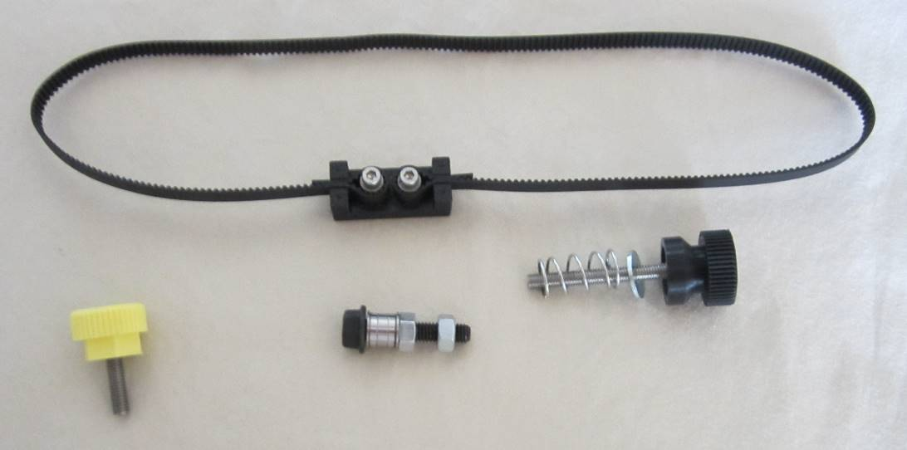

**X-axis components box ready for storage (Layer 1)**

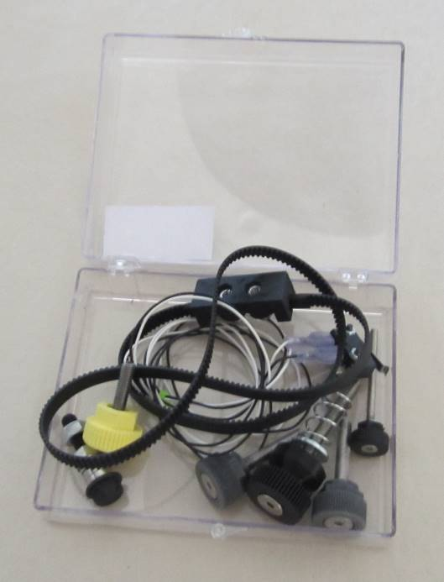

1. Remove x-axis motor and re-insert mounting hardware into the top of the motor with the smallest screw in the front left corner. Coil wire around base of motor. Store the x-axis motor in the location as shown in Case Layer Drawing 3.

**X-axis motor (Layer 3)**

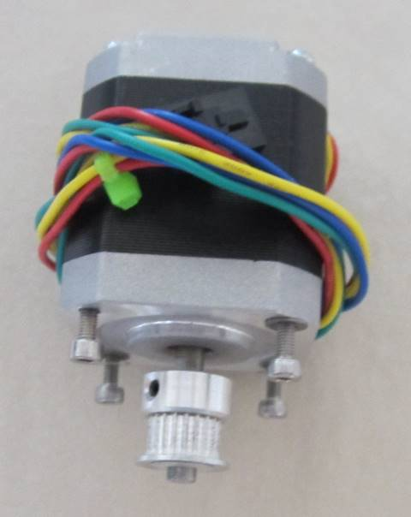

1. Remove lead screw knob by loosening set screw and set aside. Remove top frame plate, lifting the bearing from the lead screw at the same time. Store flat head screws and bearing in plastic case for z-axis and frame components as shown in Case Layer Drawing 1. Place top frame plate in location as shown in Case Layer Drawing 2.

**Top frame plate (Layer 2), lead screw knob, bearing (Layer 1) and flat head screws (Layer 1)**

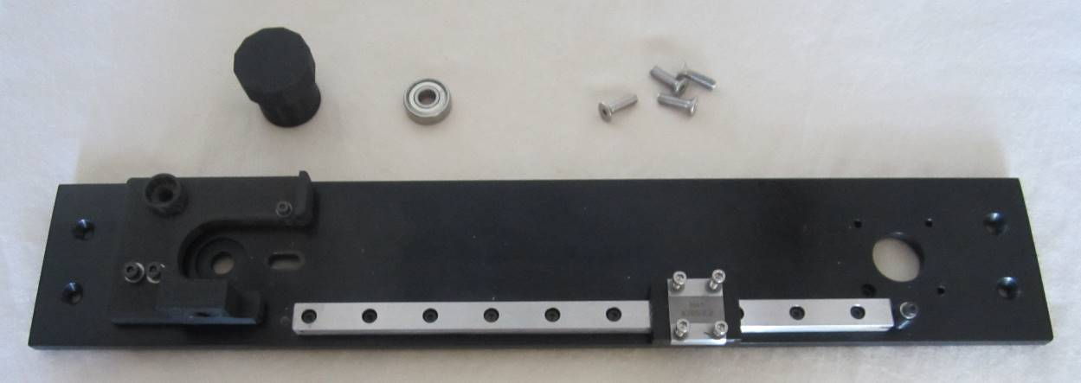

1. Remove blue thumbscrew and front clamp from front of print board plate. Remove red thumbscrews that attach print board plate to diamond plate and remove print board plate. Remove rear clamps from print board plate, and reinsert mounting hardware into the print board plate. Remove print board spacer and springs. Place springs on red thumbscrews and reinsert into print board plate. Place front and rear board clamps, print board spacer, and blue thumbscrew into the plastic case for y-axis components as shown in Case Layer Drawing 1. Place print board plate in location as shown in Case Layer Drawing 3 underneath other components in this location.

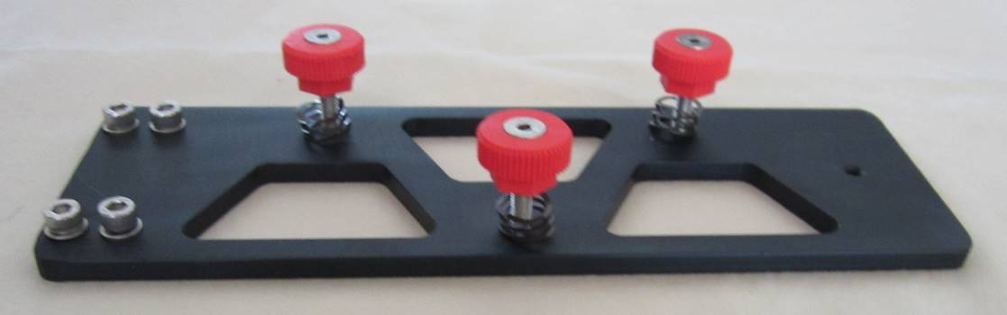

**Print board plate, springs and red thumbscrews (Layer 3)**

**Print board spacer, front and rear board clamps and blue thumbscrew (Layer 1)**

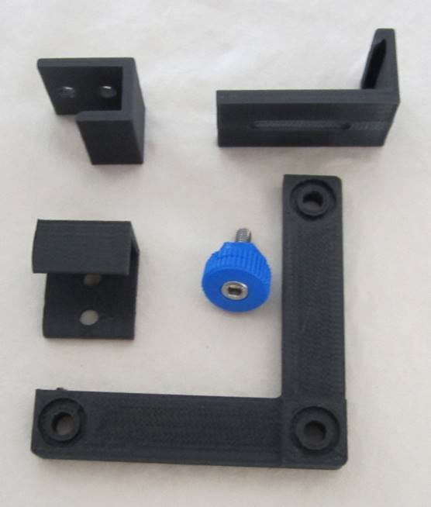

1. Remove diamond plate. Re-insert mounting hardware into the y-axis carriage and y-axis belt clamp in the locations from which they were removed. Store diamond plate in plastic box for y-axis components as shown in Case Layer Drawing 1.

**Diamond plate (Layer 1)**

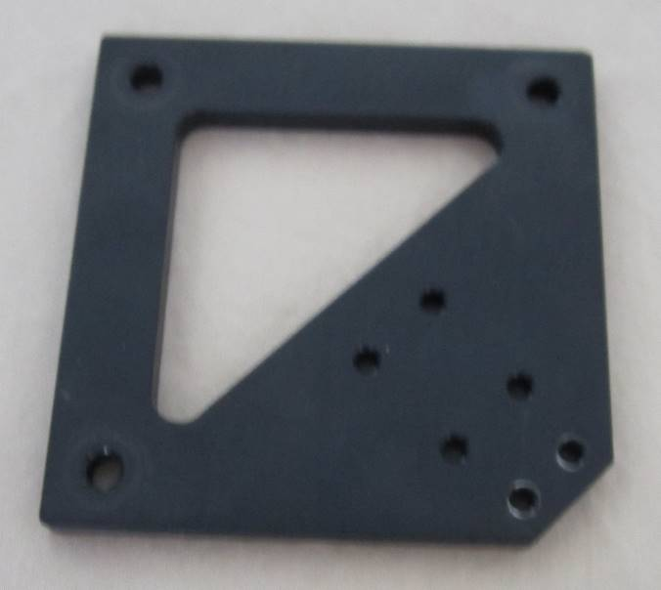

1. Remove front idler bolt located in slotted hole on y-axis plate and replace nut on end. Remove y-axis belt. Store idler bold and y-axis belt in plastic case for y-axis components as shown in Case Layer Drawing 1.

**Y-axis belt and idler bolt (Layer 1)**

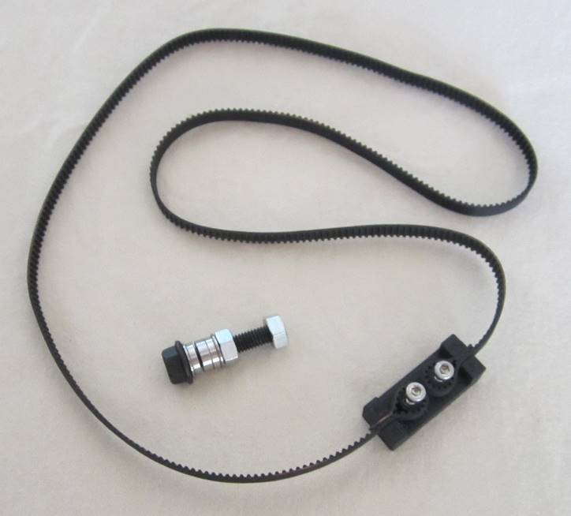

1. Remove y-axis plate by removing three flat head screws. Remove remaining idler bolts and replace nuts on ends. Coil y-axis limit switch wire and pass plug end through the coil so that it doesn’t become unraveled. Store idler bolts and flat head screws in plastic case for y-axis components as shown in Case Layer Drawing 1. Place y-axis components plastic box in location as shown in Case Layer Drawing 1. Place y-axis plate in location as shown in Case Layer Drawing 3.

**Y-axis plate (Layer 3), idler bolts (Layer 1) and flat head screws (Layer 1)**

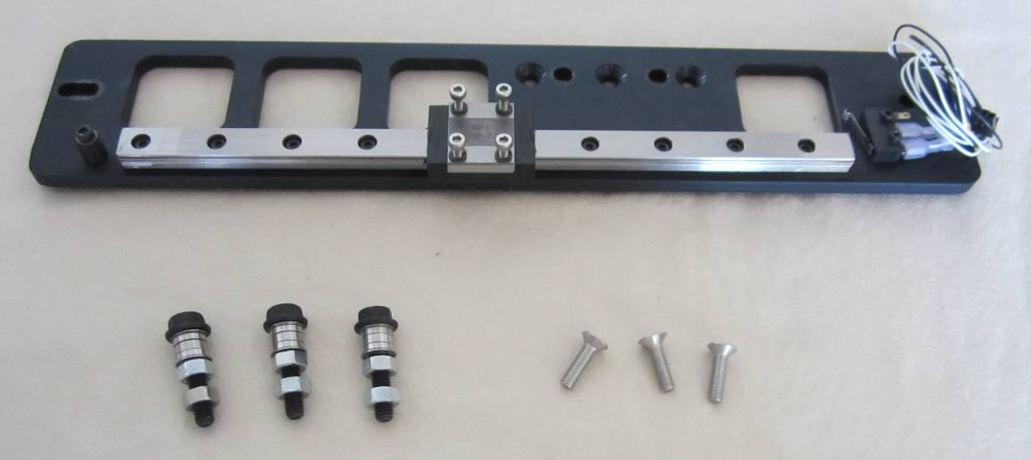

**Y-axis components box ready for storage (Layer 1)**

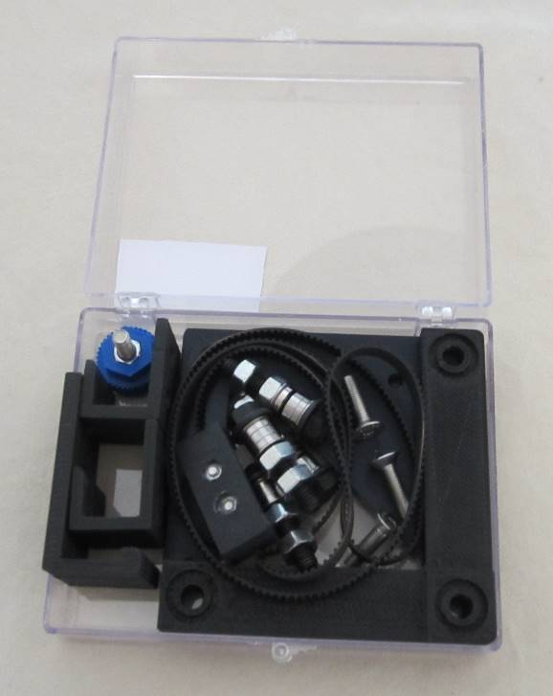

1. Remove y-axis motor and reinsert mounting hardware into the top of the motor. Coil wire around base of motor and pass plug end under the coil to prevent from unraveling. Store y-axis motor in location as shown in Case Layer Drawing 3.

**Y-axis motor (Layer 3)**

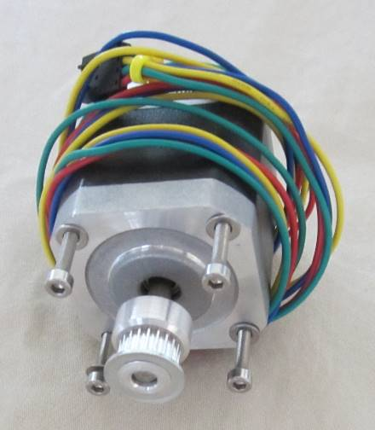

1. Remove four flat head screws that attach L-plate to the z-axis carriage. Rotate lead screw to remove L-plate. Replace flat head screws in z-axis carriage. Coil z-axis limit switch wire and place plug end through coil to hold in place. Store L-plate in location as shown in Case Layer Drawing 2.

**L-plate subassembly (Layer 2)**

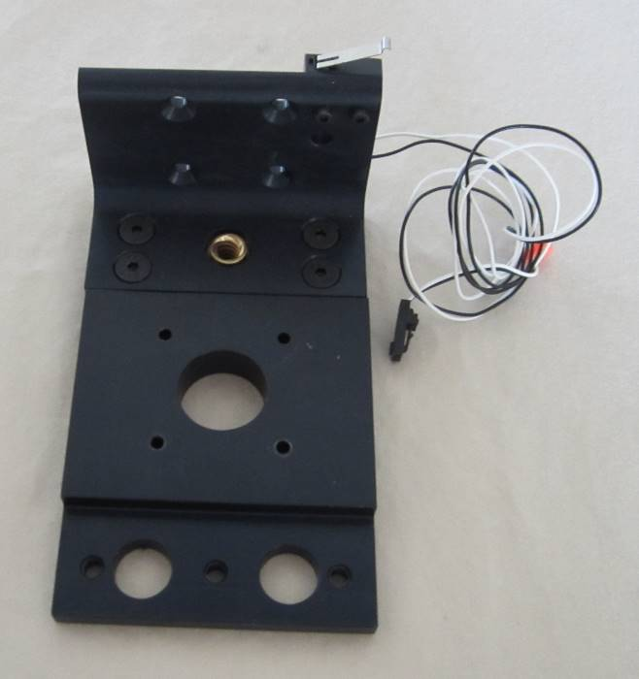

1. Remove gold thumb screws that connect z-axis motor to bottom frame plate and remove z-axis motor mount. Remove z-axis motor. Place z-axis motor mount on bottom of z-axis motor and insert and tighten gold thumbscrews. Place lead screw knob on top of lead screw and lightly tighten set screw. Store the z-axis motor in location as shown in Case Layer Drawing 3.

**Z-axis motor, lead screw knob, z-axis motor mount and gold thumbscrews (Layer 3)**

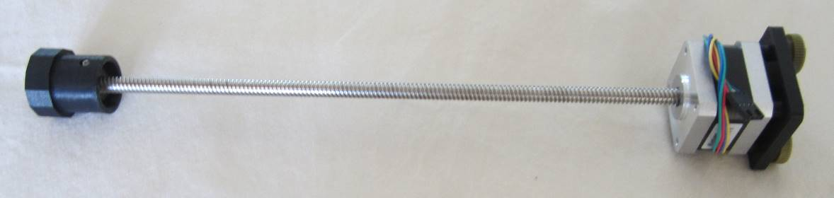

1. Remove green thumbscrews that attach printer legs to left and right side frames and remove printer legs. Remove printer feet from printer legs and replace printer foot mounting hardware back into the printer feet. Store green thumbscrews in plastic case for z-axis and frame components as shown in Case Layer Drawing 1. Store printer feet with mounting hardware in location as shown in Case Layer Drawing 4. Store printer legs in location as shown in Case Layer Drawing 1.

**Printer feet (Layer 4), printer legs (Layer 1) and green thumbscrews (Layer 1)**

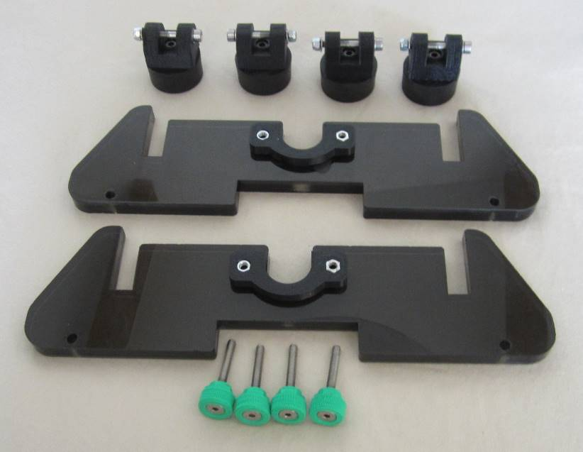

1. Remove bottom plate from left and right side frames. Store bottom frame plate in location as shown in Case Layer Drawing 2. Store flat head screws in plastic case for z-axis and frame components as shown in Case Layer Drawing 1. Store z-axis and frame components case in location as shown in Case Layer Drawing 1.

**Bottom frame plate (Layer 2) and flat head screws (Layer 1)**

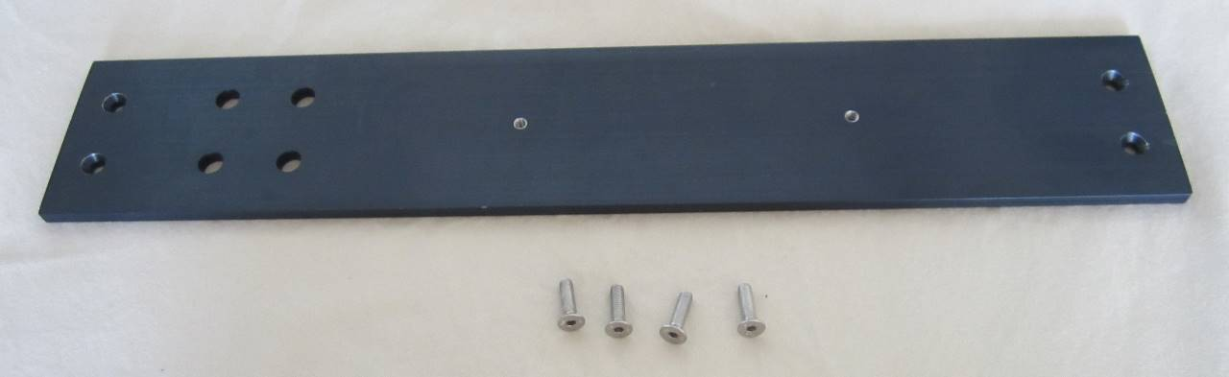

**Z-axis and frame components box ready for storage (Layer 1)**

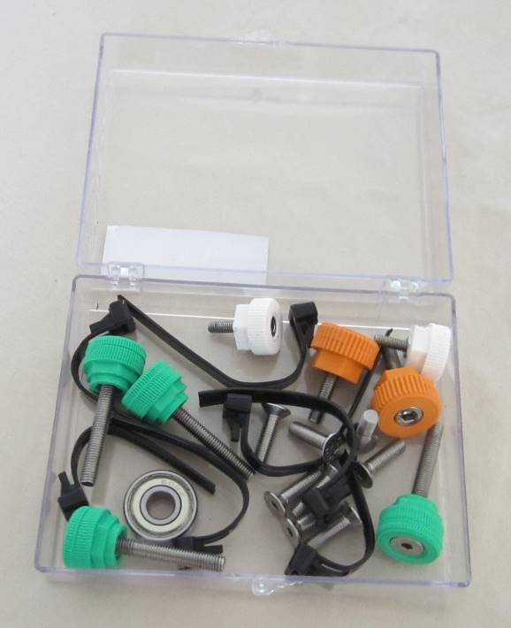

1. Replace side channels on left and right side frames. Insert black thumbscrews and tighten to attach side covers to side frames. Be careful that the z-axis carriage does not slide off of the rail. Store left side assembly and right side assembly in locations as shown in Case Layer Drawing 2.

**Left side assembly (Layer 2)**

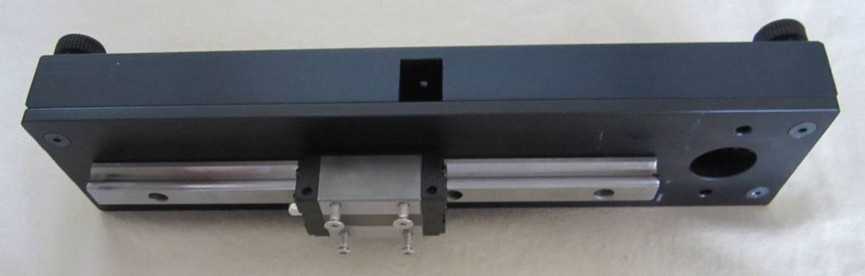

**Right side assembly (Layer 2)**

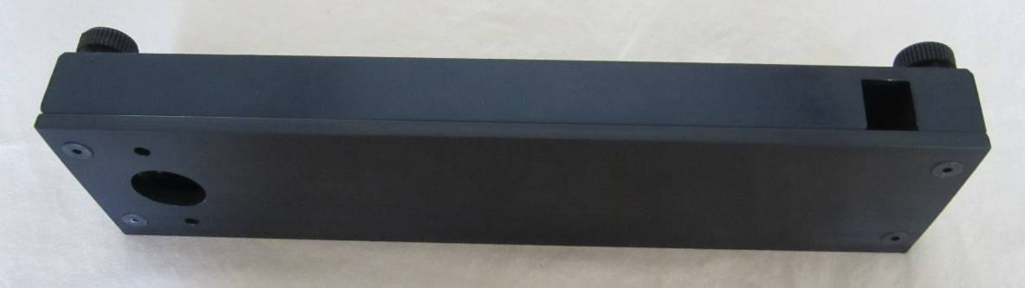

1. Compare the following photos of completed case layers with the layers of your printer case to ensure that all components are in their proper locations.

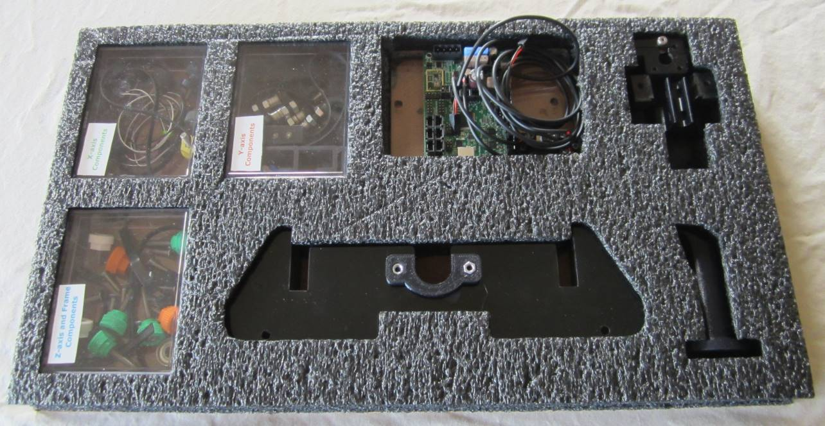

**Completed Layer 1**

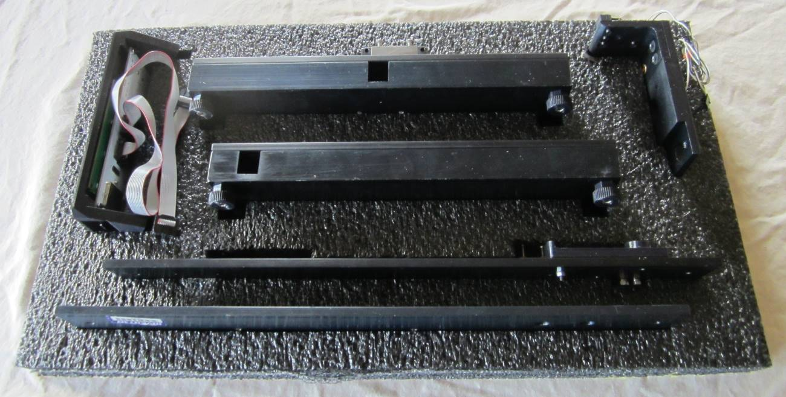

**Completed Layer 2**

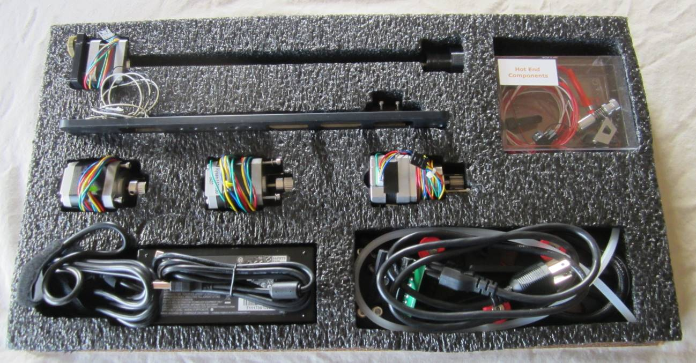

**Completed Layer 3**

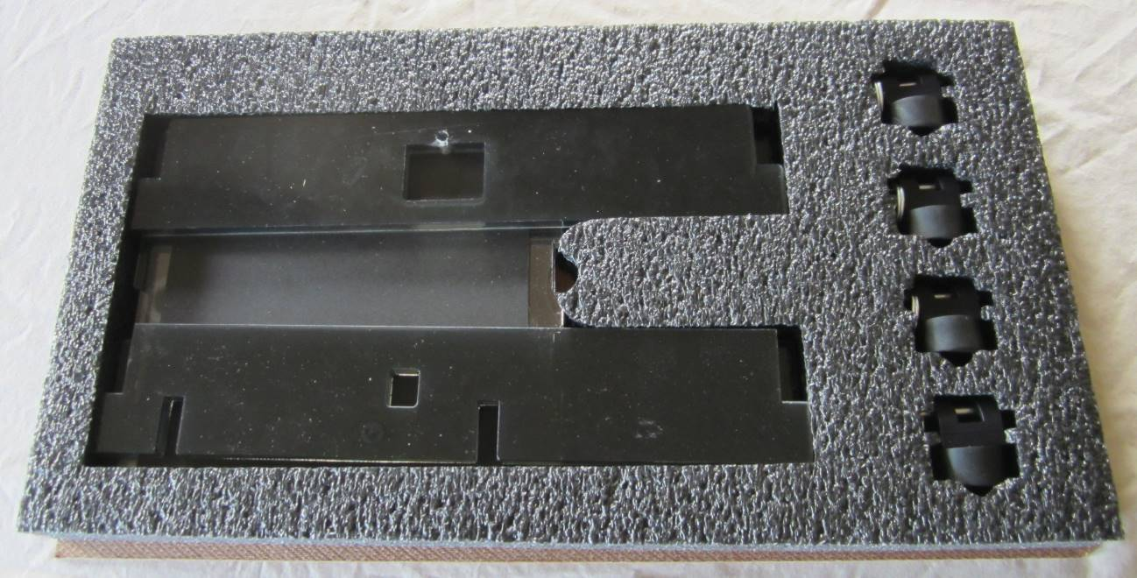

**Completed Layer 4**