INVENT3D Printer Kit
Assembly Instructions

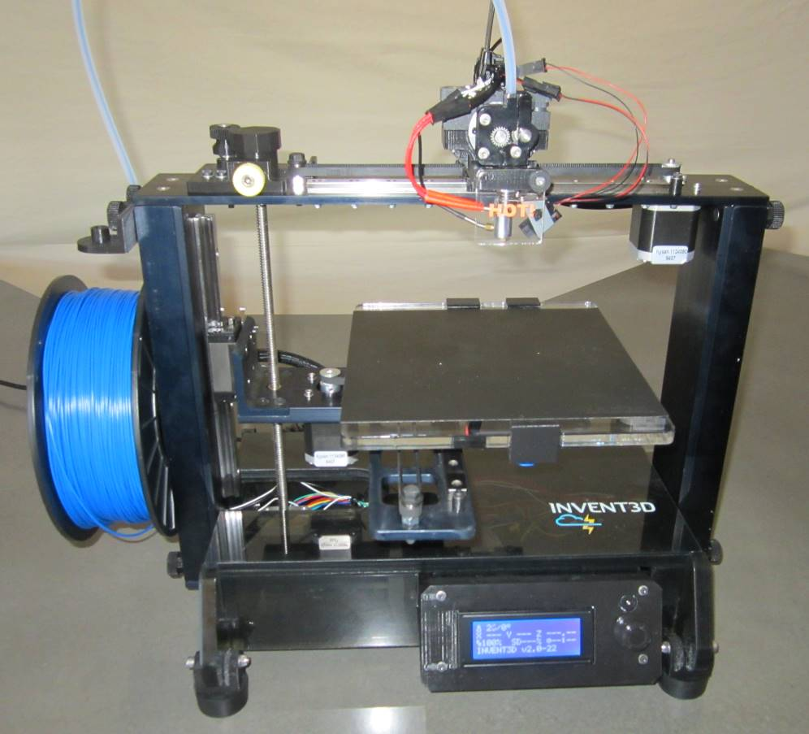

DRAFT – REVISION 3
August 2, 2016

I. Printer Kit Case Layout
The printer kit components are organized in four layers in the printer kit case. The custom-cut foam layers allow components and subassemblies to be re-packed in the same manner when disassembled. These layers are labeled from the top down within the case, meaning Layer 1 is the top layer and Layer 4 is the bottom layer. A detailed drawing and photo(s) of each layer is included below to ensure that all pieces are accounted for and for ease of subsequent assemblies.

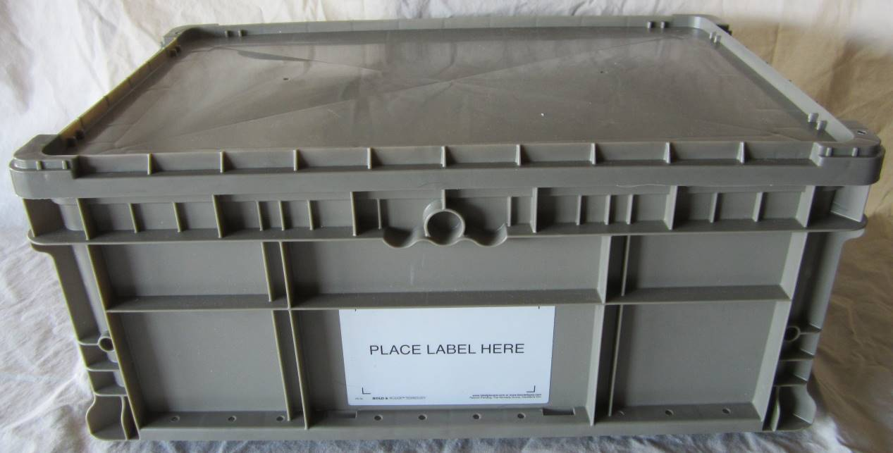
Layer 1
Layer 2
Layer 3
Layer 4
Printer Kit Case

Layer 1
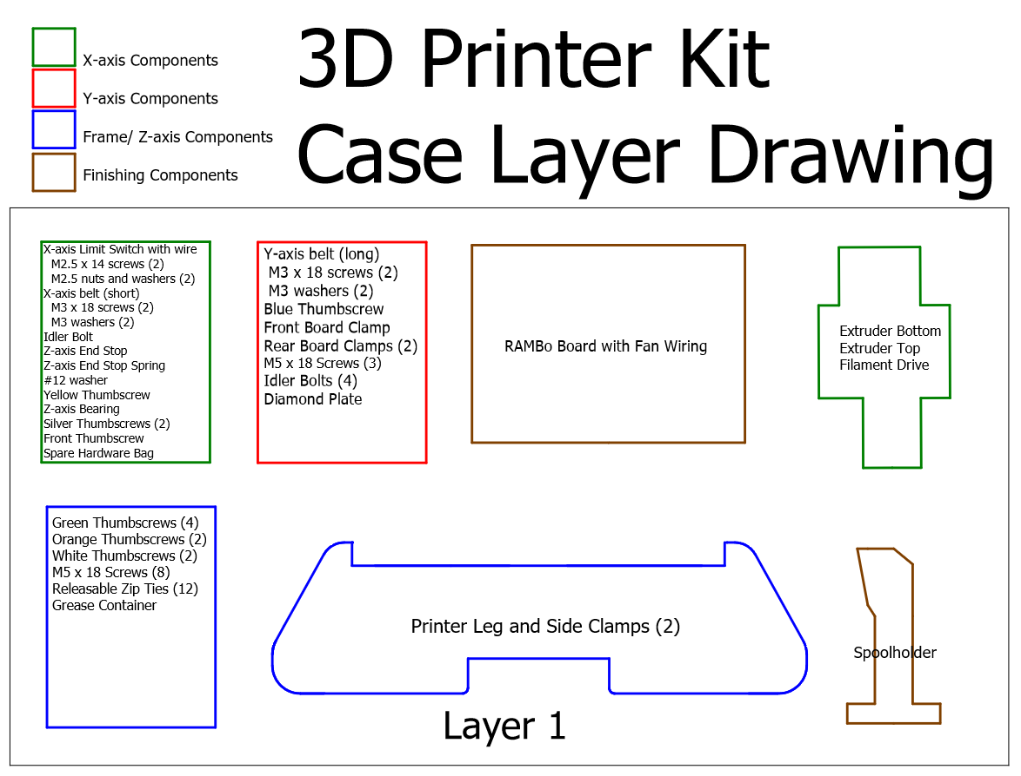

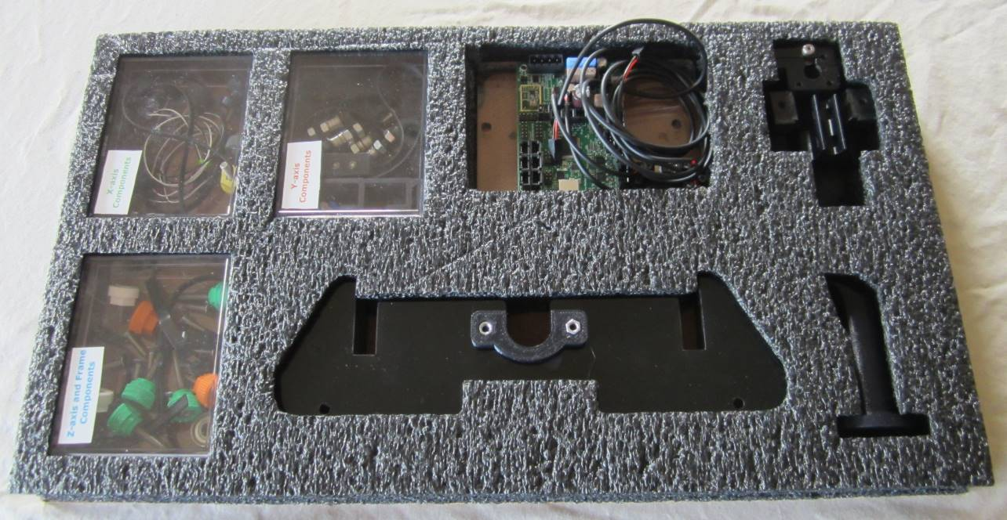
Layer 1

Layer 2
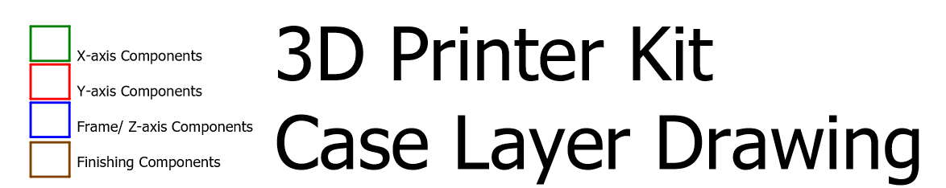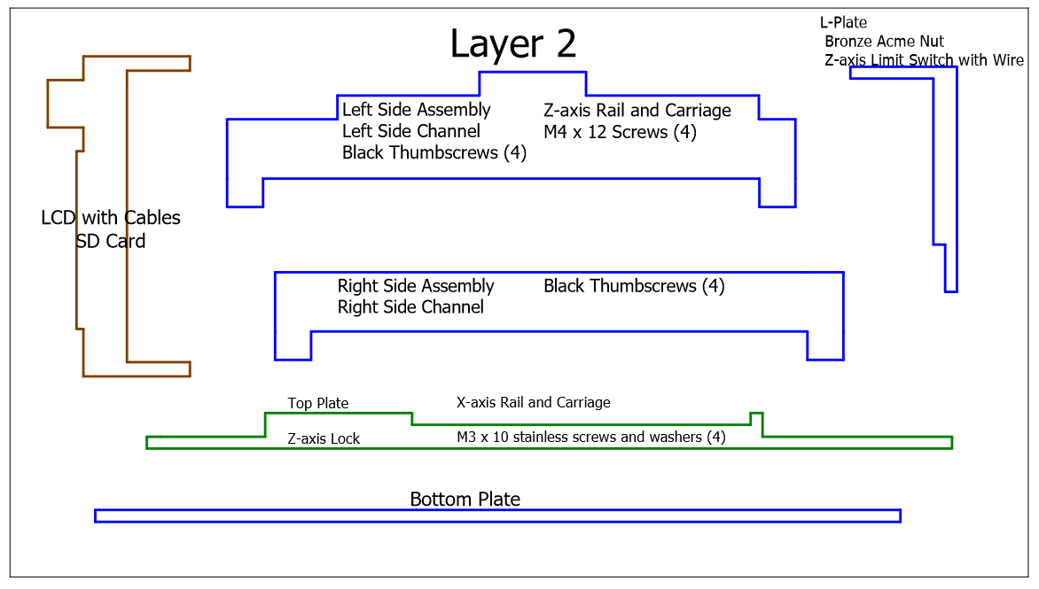

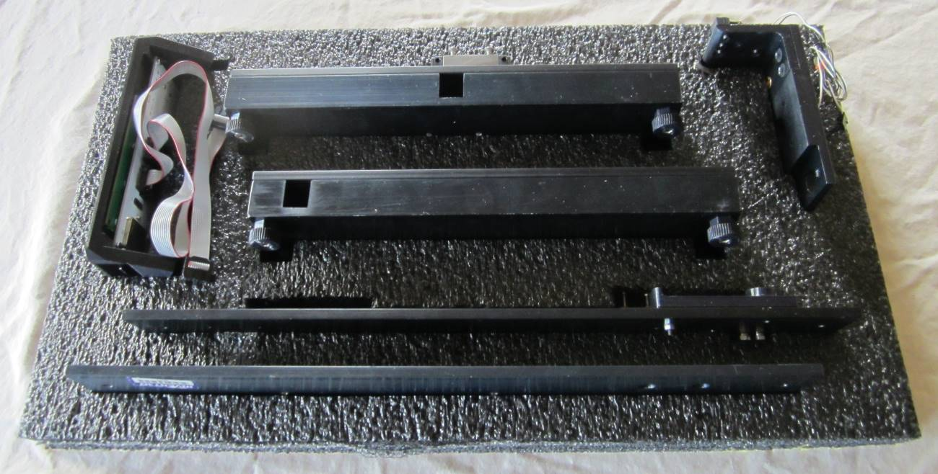
Layer 2 with top foam removed

Layer 3
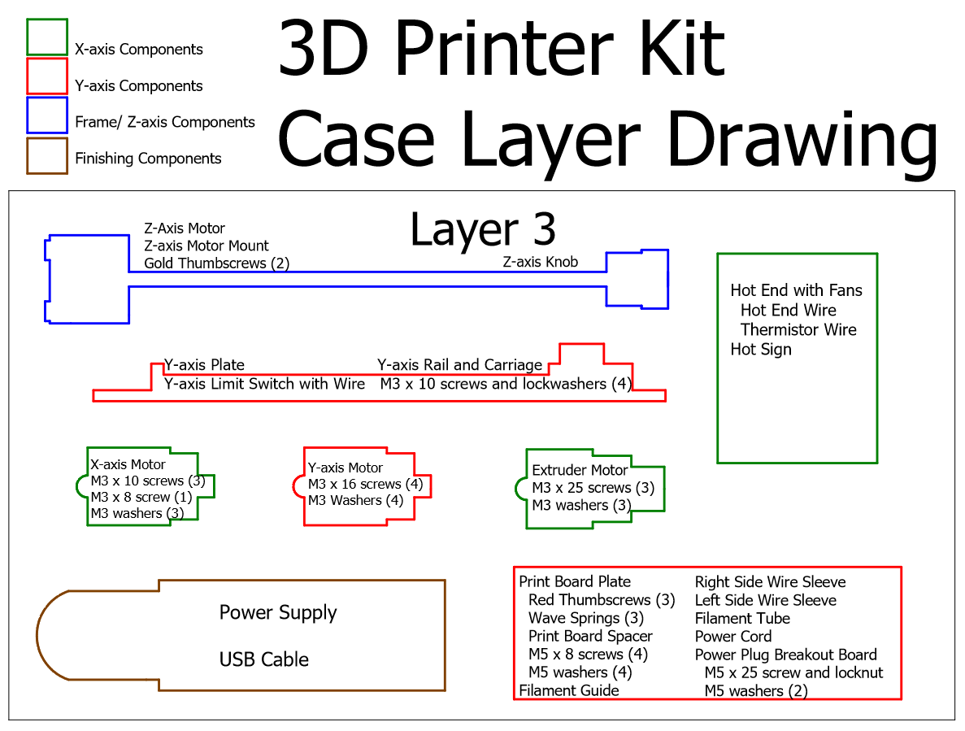

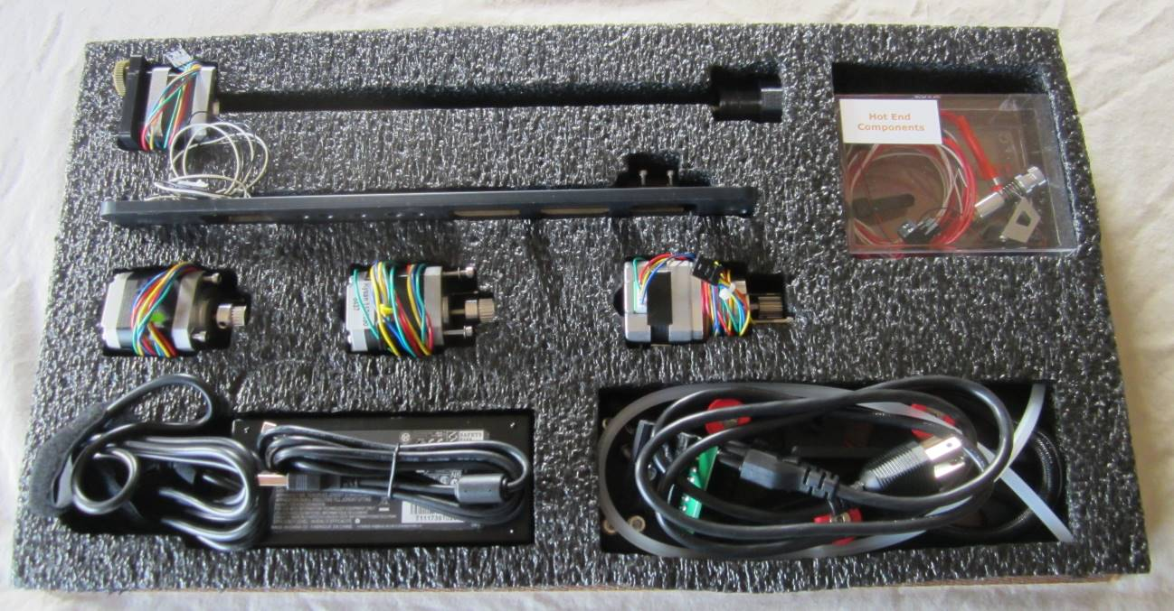
Layer 3 with top foam removed

Layer 4
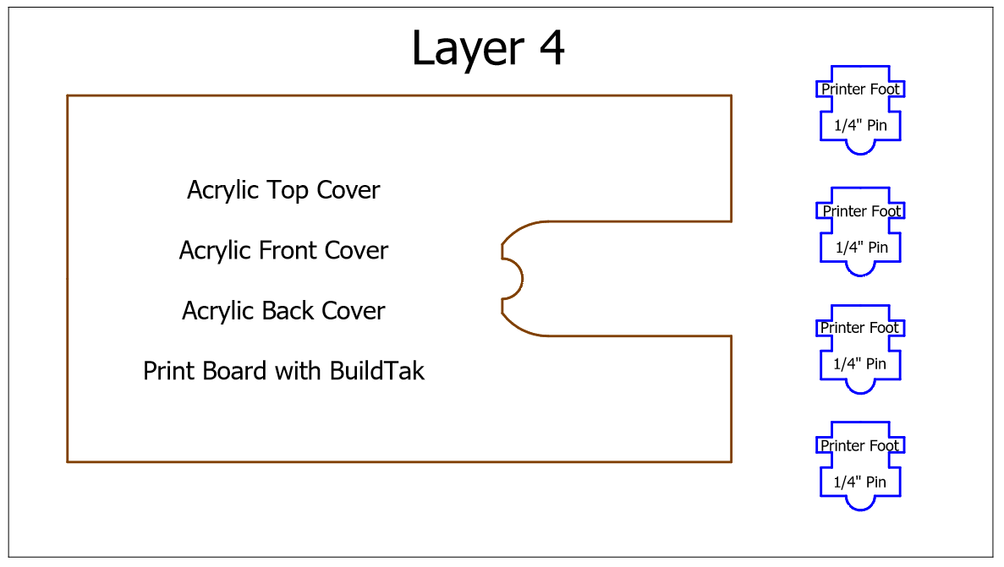

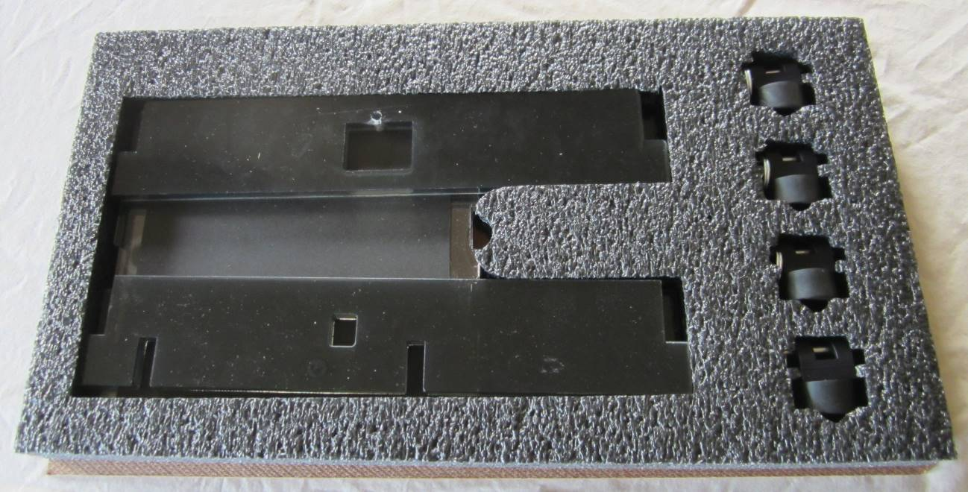
Layer 4

II. General Assembly Instructions
The INVENT3D Printer is a sophisticated, electro-mechanical system. It is imperative that all procedures are read and followed exactly to avoid damage that would prevent full and correct assembly and/or operation of the printer. AST2 is not responsible for damage resulting from failure to follow procedures.
The procedures will provide detailed information about each printer assembly and printer component that will be used to build a functioning INVENT3D Printer. Procedures are also provided for disassembly of the printer for storage and reassembly by subsequent users.
It is imperative to implement the following general guidance when assembling the INVENT3D printer kit:

- Unless otherwise noted, printer kit components and subassemblies are not to be disassembled; disassembly should return the printer kit to the same condition in which it arrived.
- Screws that are black anodized should not be removed.
- Always hand tighten screws first to ensure that the screw is threaded properly and avoid cross-threading.
- Screws do NOT need excessive force to tighten.
- If a screw is hard to turn, make sure that the correct screw is being used in the correct location.

Contact Applied Systems & Technology Transfer, LLC (AST2) if any parts are missing or not functioning properly. Leave a note in the kit so that the other users are aware of the missing/malfunctioning parts to ensure that corrective actions are completed prior to its assembly. AST2 welcomes and appreciates any comments on the printer, assembly or operation as feedback is used in its continuous improvement process.

III. Detailed Assembly Instructions

- Connect the left side assembly and the right side assembly with the bottom plate using four M5 x 18 flat head screws from the z-axis plastic box

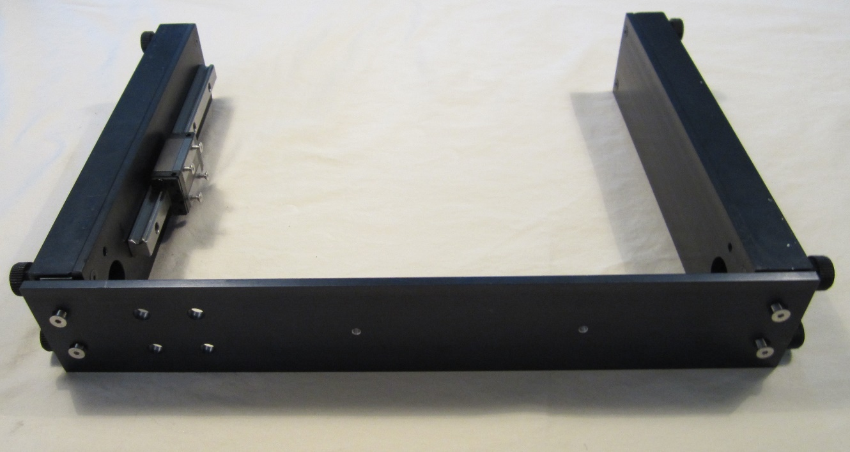
Screw locations. Countersinks on bottom plate should be facing you.

- Connect printer feet to the printer legs. There are currently two variations of printer foot mounting hardware: hitch pins (newer models) and screws with lock nuts (older models).

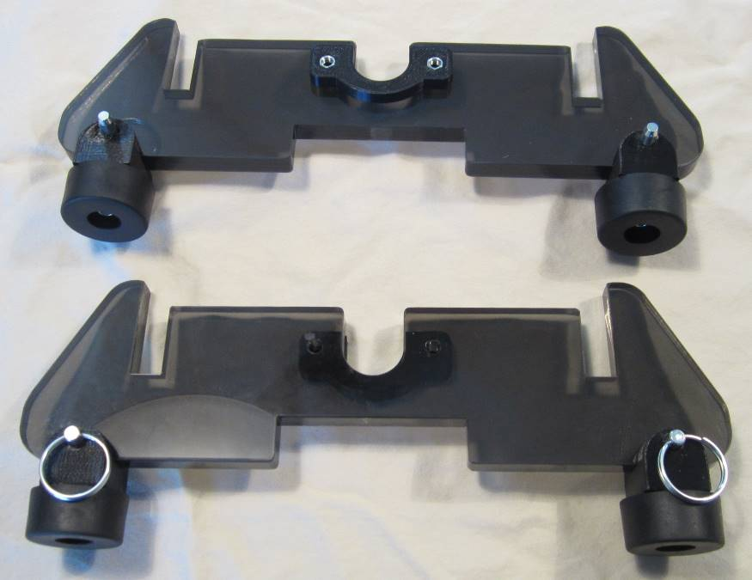
Hitch pin rings or screw heads should be on outside of printer leg.
Inside of printer leg has side clamp attached.

- Remove left side channel by unscrewing the four black thumbscrews. Screw the two green thumbscrews through the left side frame and into the printer leg until tight. Re-attach the left side channel with the four black thumbscrews.

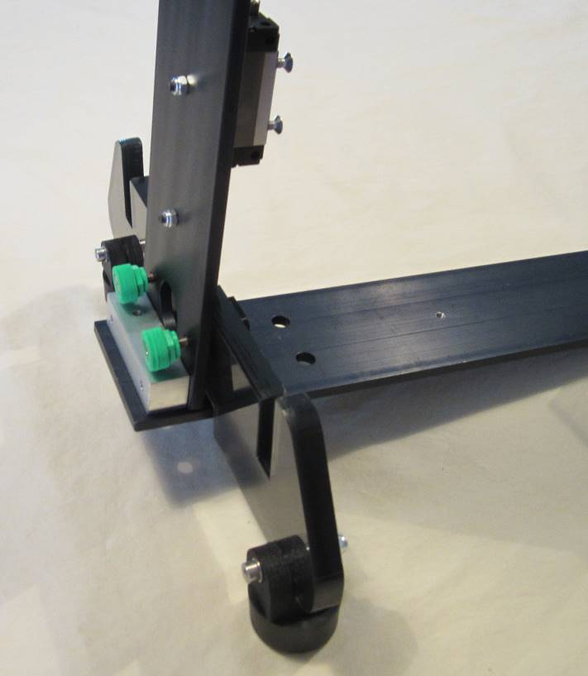
Insert from outside of fame and into printer leg.

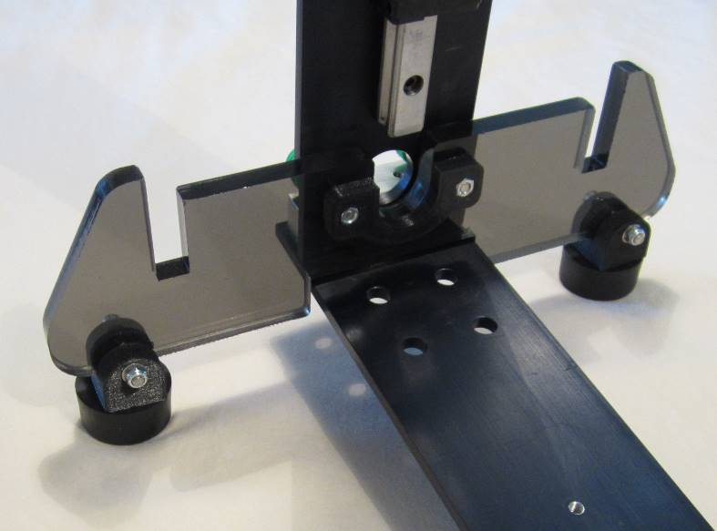
Nuts (older models) on printer feet should face inside of printer. Hitch pin rings (newer models) should face outside.

- Repeat step 3 for right side.
- Mount the z-axis motor to the bottom plate using the two gold thumbscrews and the z-axis motor mount.

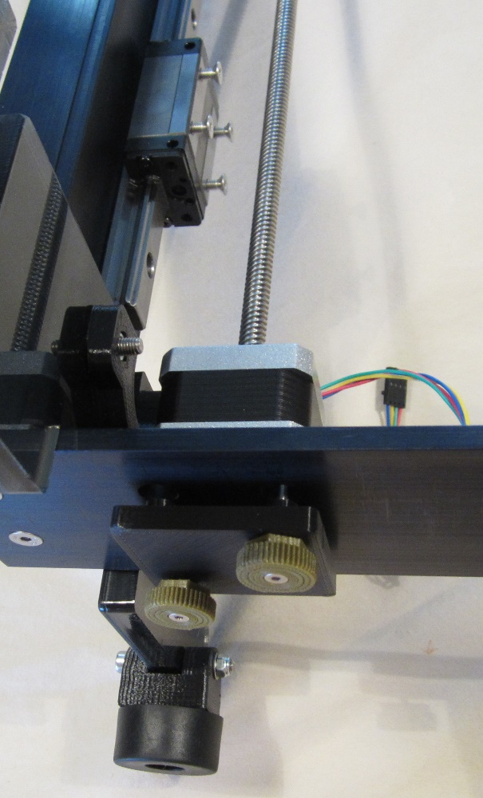
Wire leaves motor at rear of printer.
Insert from bottom of printer, through motor mount and frame, and into vacant holes in motor.

- Remove the lead screw knob by loosening the small set screw. Remove the four screws from the z-axis carriage. Thread the L-plate subassembly onto the z-axis lead screw and replace the z-axis knob.

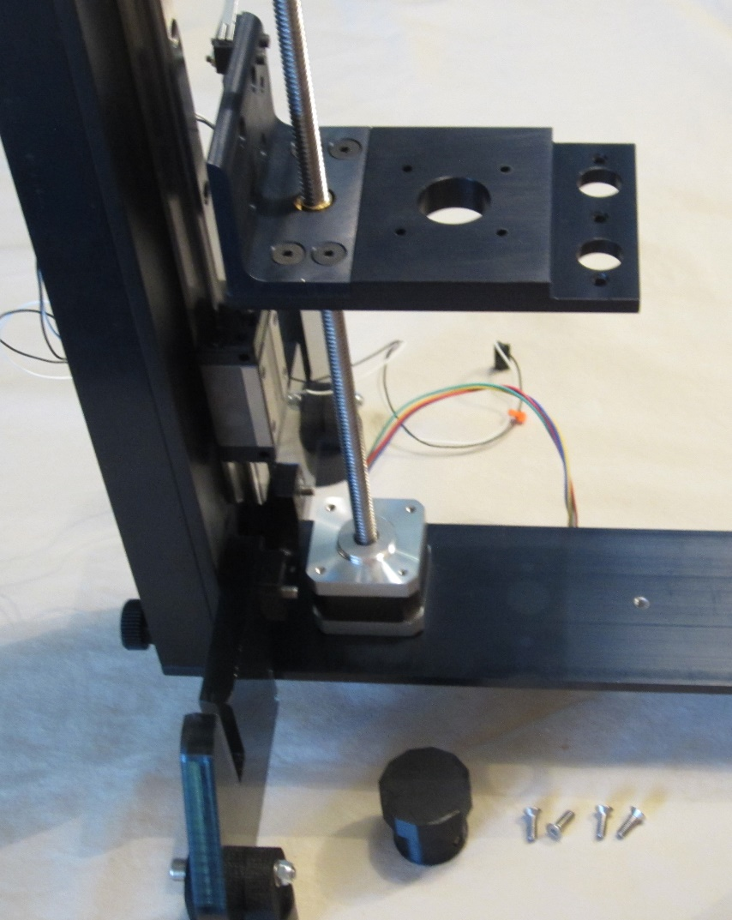
Lead screw knob and flat head screws from z-axis carriage removed.
Rotate lead screw counter-clockwise to lower L-plate.

- Replace lead screw knob. Rest the printer assembly on its left side. Align the L-plate with the holes on the carriage and insert the four screws removed in the previous step and tighten.

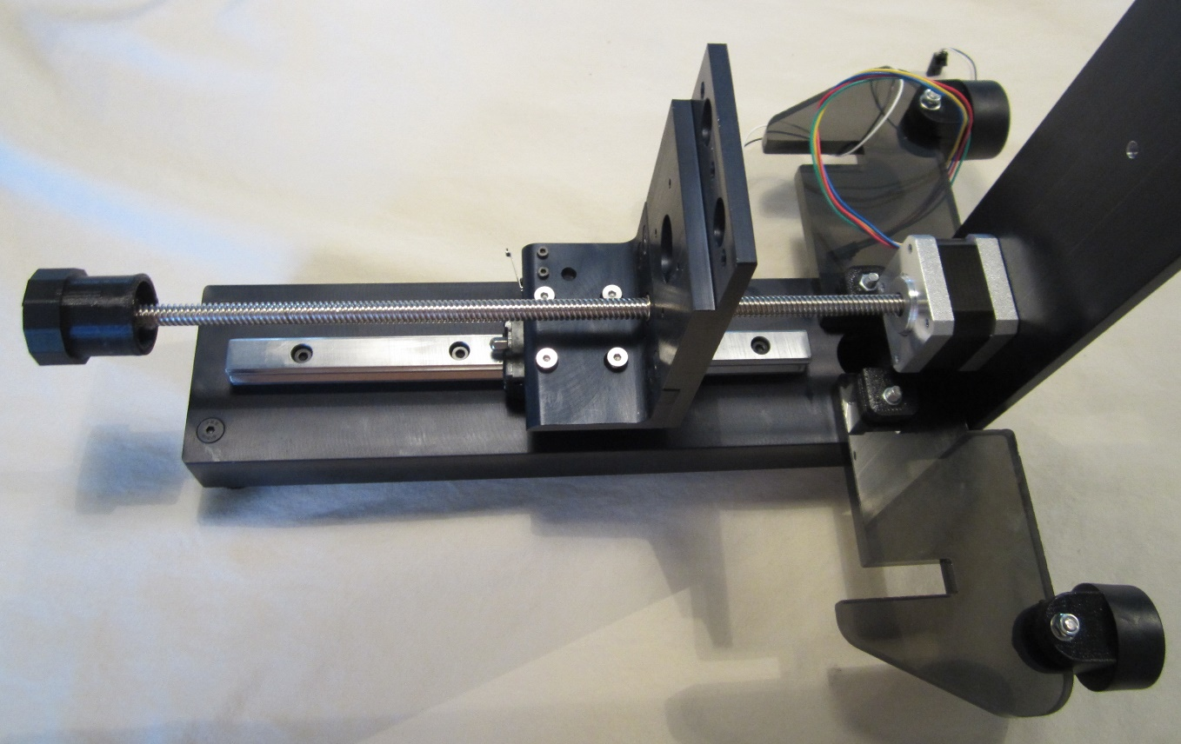
Insert screws through L-plate and into rail carriage.
Lead screw knob replaced.

- Attach the four idler bolts to the y-axis plate.

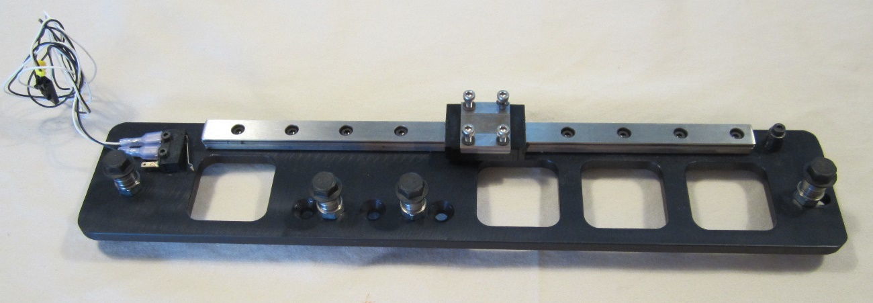
Y-axis carriage.
Idler bolt locations.

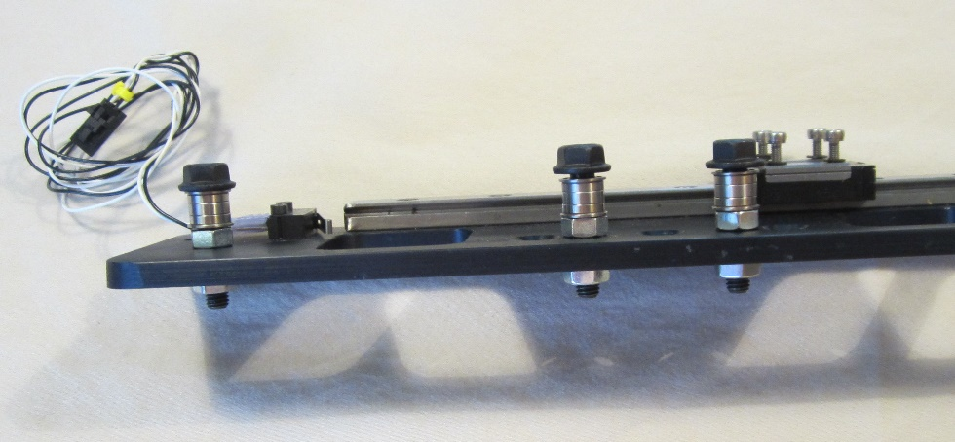
Tighten nuts onto ends of these three bolts to lock firmly into place. Nut on idler bolt in slotted hole (not pictured) does not need to be tight to allow the bolt to slide along slot.

- Remove four screws and lock washers from y-axis carriage. Align the diamond plate and attach to the carriage with the four screws.

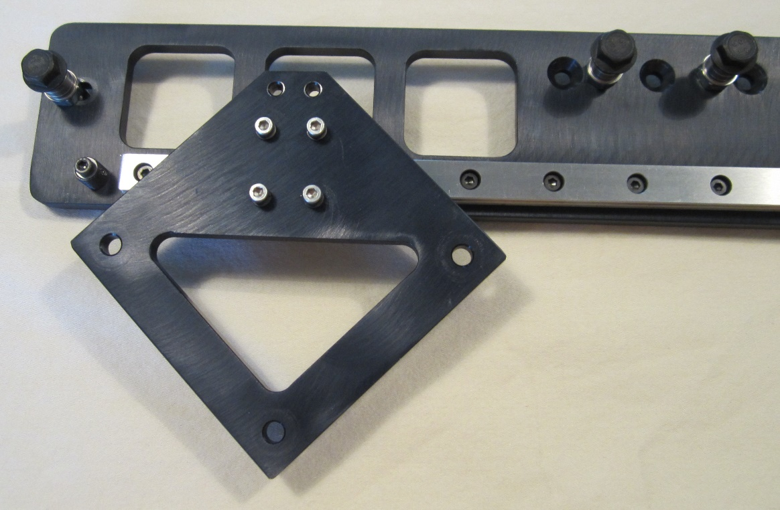
Insert screws with lock washers through diamond plate and into carriage.

- Attach the y-axis plate to the L-plate using three M5 flat head screws from the y-axis plastic box.

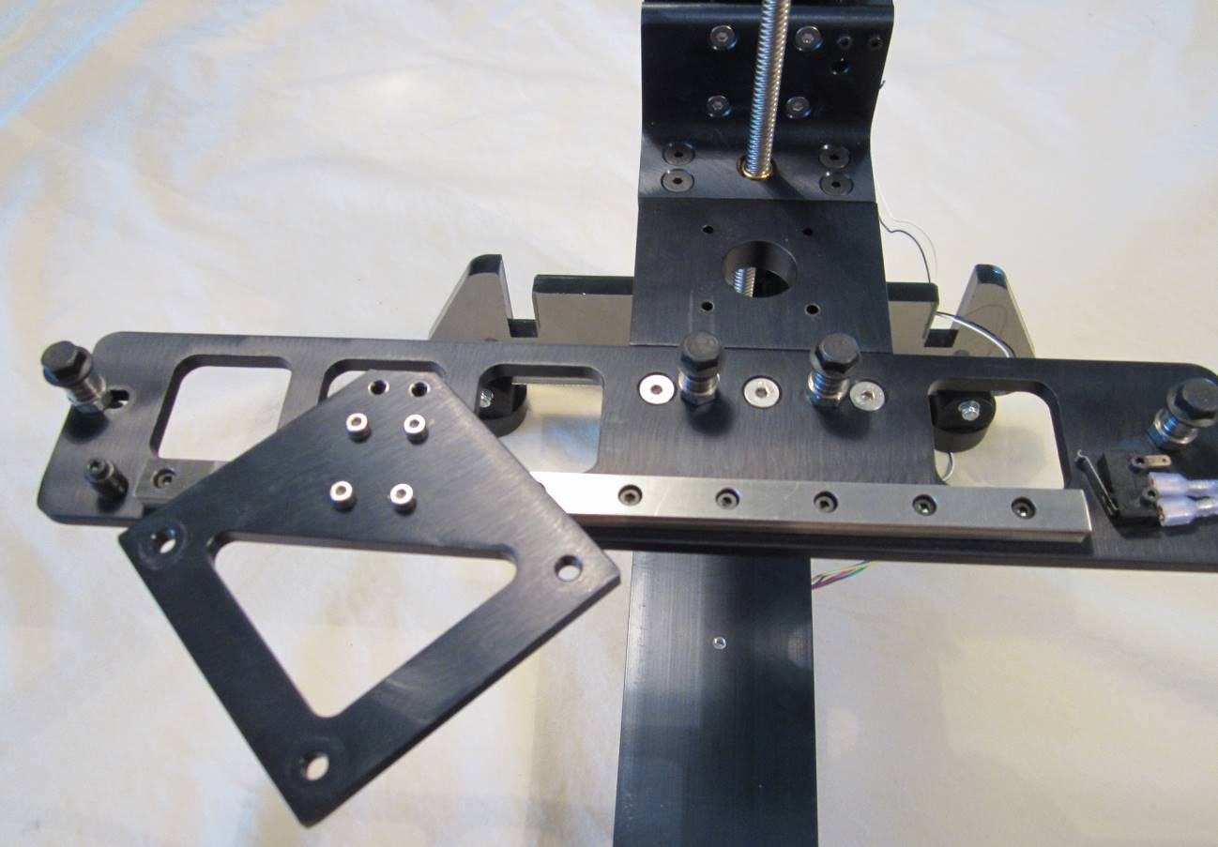
Insert flat head screws through y-axis plate and into L-plate subassembly.

- Attach the y-axis motor to the L-plate assembly using screws found in y-axis motor.

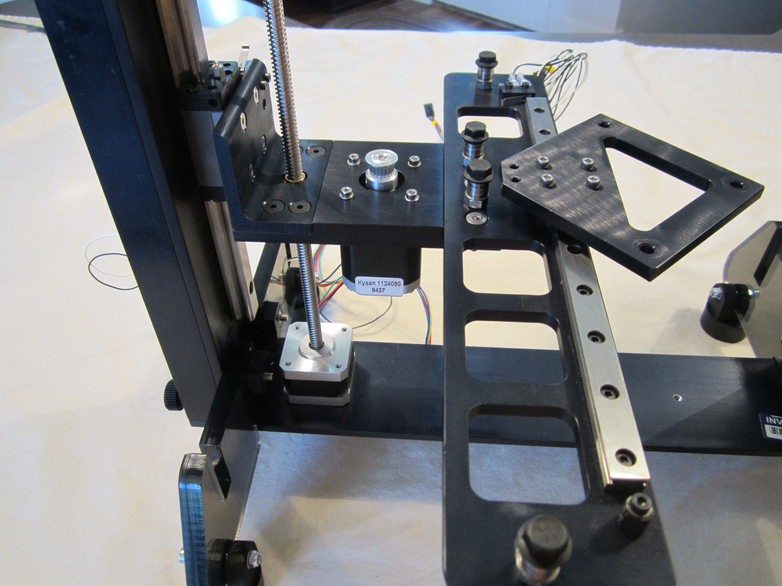
Wire should leave motor at rear of printer.
Insert screws with washers through L-plate assembly and into top of motor.

- Remove the z-axis knob and align the top plate. Connect the top plate to the left and right sides using M5 flat head screws found in the x-axis plastic box.

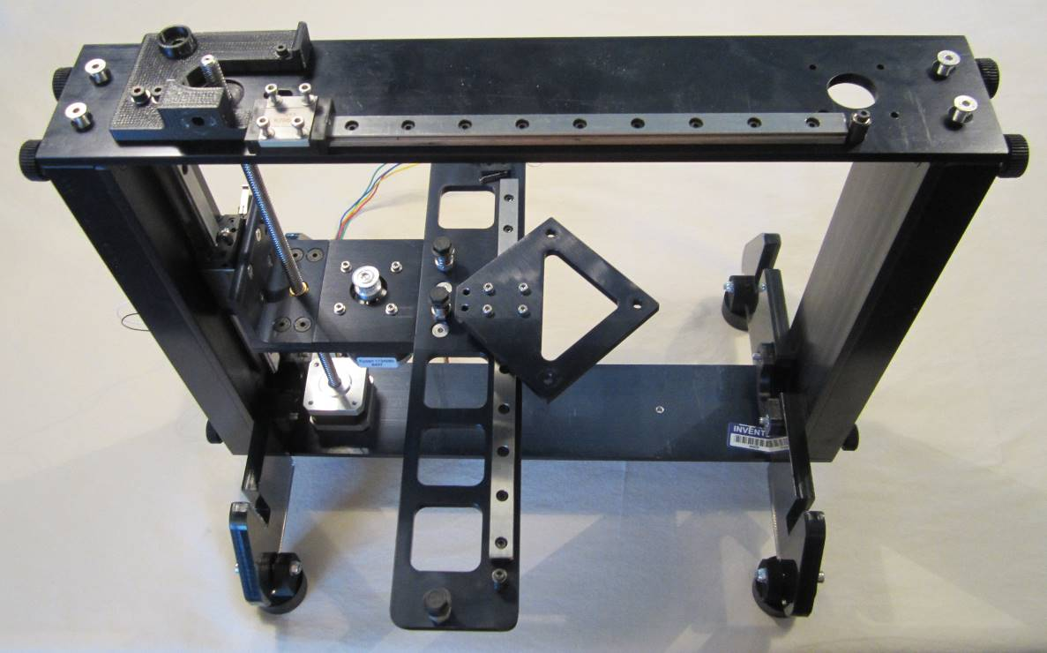
X-axis carriage.
Screw locations.
- Place the bearing on the z-axis lead screw and replace the lead screw knob. Insert the yellow thumb screw into the front to the z-axis plate near the lead screw. Attach the idler bolt to the top plate.

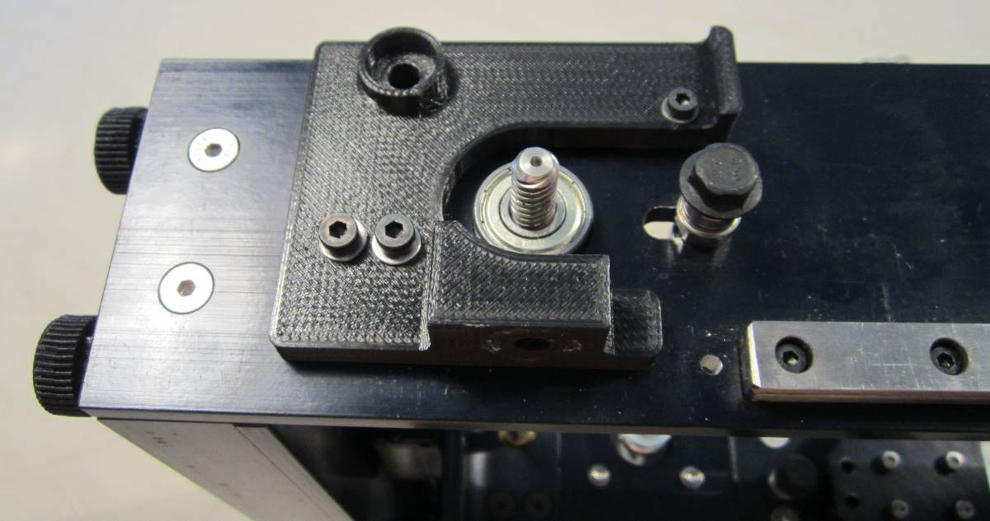
Idler bolt in slot with nut tightened loosely on end to allow movement along slot.
Bearing completely seated in cutout.

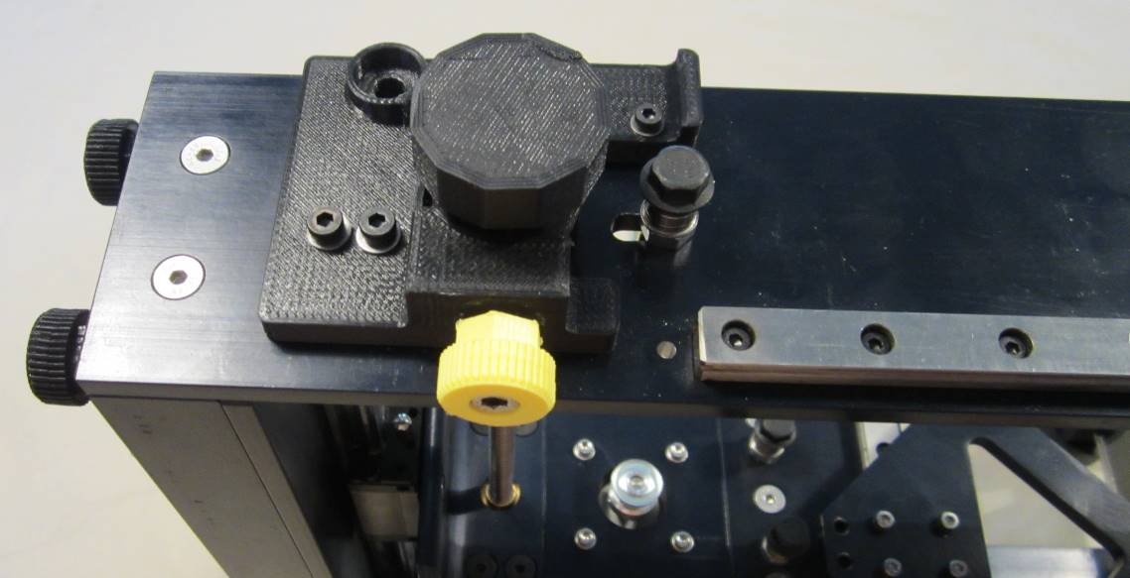
Insert yellow thumbscrew but do not tighten against knob.
Replace lead screw knob and tighten set screw.

- Attach x-axis motor, making sure that the short screw is in the front left corner.

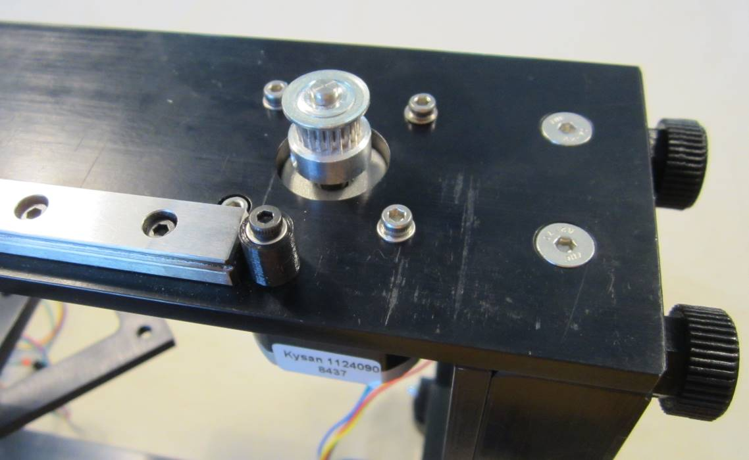
Wire leaves motor at rear of printer.
Small screw with no washer in cutout in this location.
Longer screws with washers in these positions.

- Attach the x-axis limit switch to the extruder bottom.

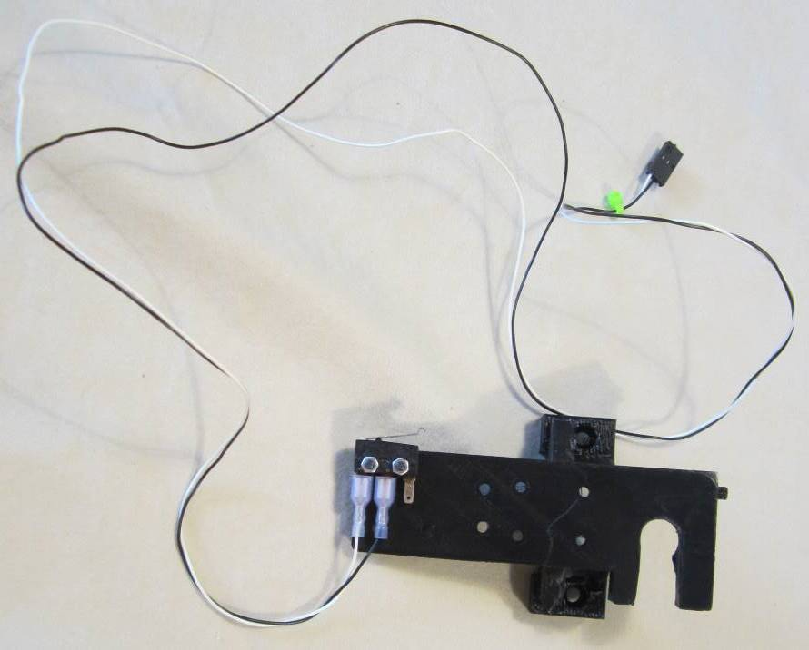
Position limit switch with lever pointing toward center of extruder bottom. Insert screws through extruder bottom and into limit switch. Tighten nuts on ends of screws.

- Attach the extruder bottom to the x-axis carriage using the four screws found in the x-axis carriage. (Refer to Step 17 photo)

- Slide hot end into the slot on the extruder bottom until it seats flush with the end of the slot.

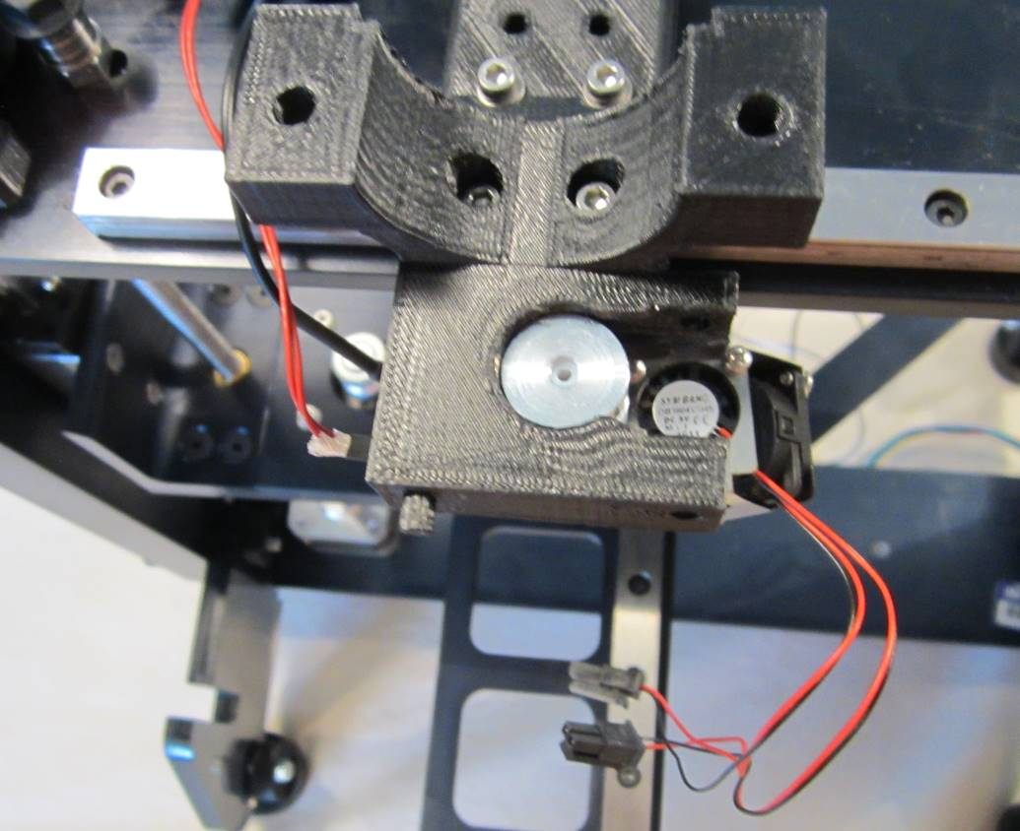
Hot end and thermistor wires on left hand side.
Fans with wiring on right hand side.
Slide hot end flush with end of slot (Step 17).
Insert screws with washers through extruder bottom and into carriage (Step 16).

- Connect the x-axis belt to the x-axis motor and idler bolt. Tighten the belt by sliding the idler bolt back and tighten. Ensure that there is sufficient tension on the belt – there should be some resistance with squeezing the belt together with your fingers.

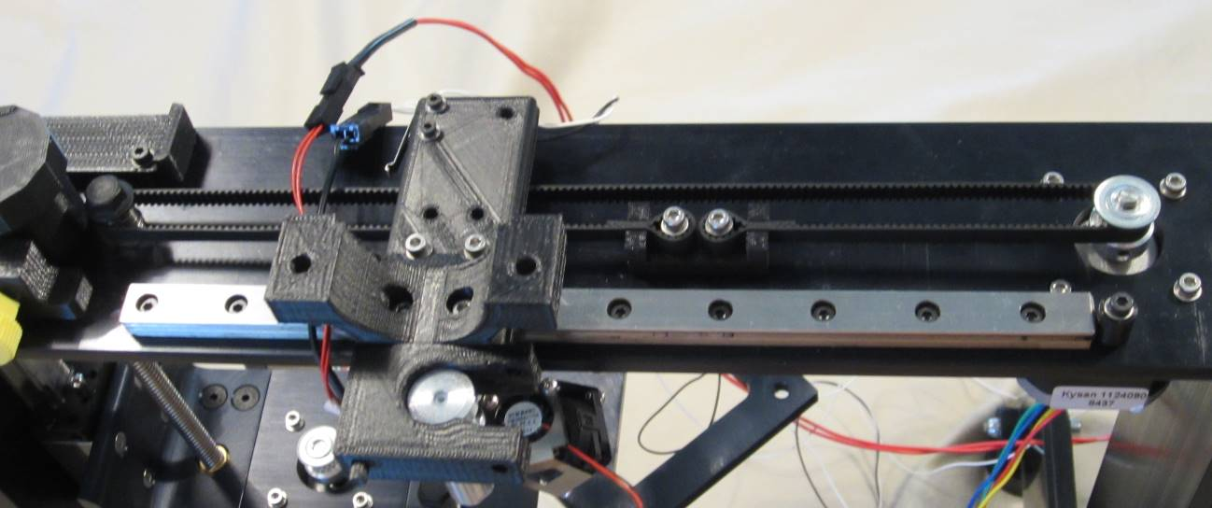
Belt around motor gear with teeth on inside.
Belt clamp on side closest to rail.
Pull idler bolt to place tension on belt. Tighten bottom nut to lock in place.

- Remove the screws from the belt clamp. Align the holes in the belt clamp with those in the extruder bottom. Connect the extruder bottom to the belt clamp using the screws previously removed.

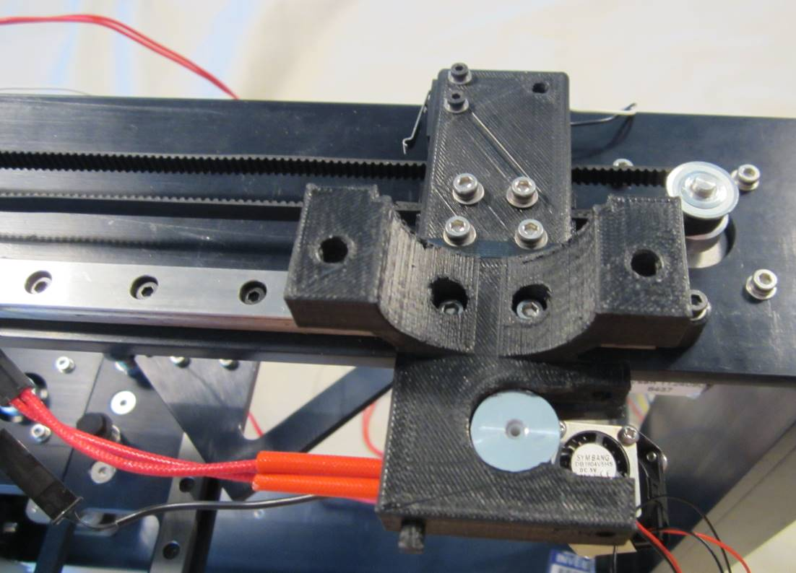
Insert screws with washers through extruder bottom and into belt clamp.
- Connect the y-axis belt to the y-axis motor and idler bolts. Tighten the belt by sliding the slotted idler bolt back and tighten. Ensure that there is sufficient tension on the belt – there should be some resistance with squeezing the belt together with your fingers.

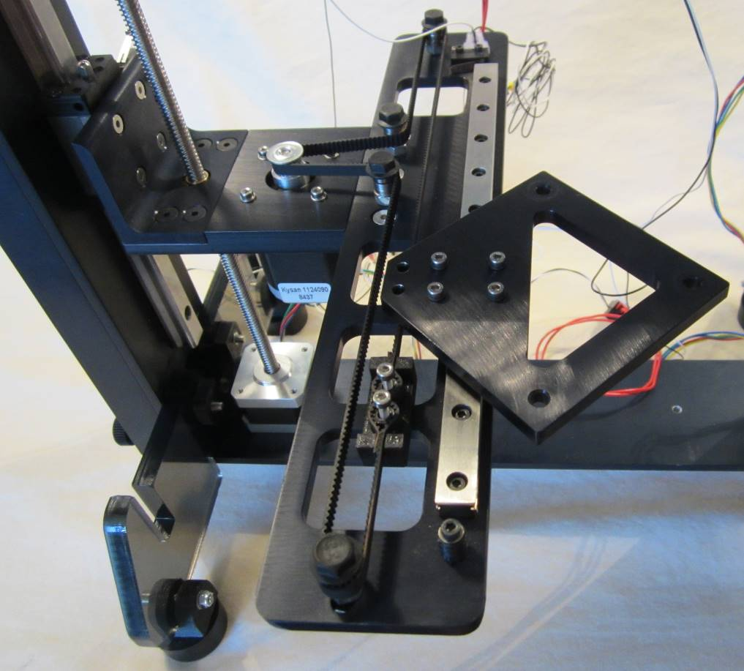
Belt around gear with teeth on inside.
Belt clamp on side closest to rail.
Pull idler bolt to place tension on belt. Tighten bottom nut to lock idler bolt in place.

- Remove the screws from the y-axis belt clamp and align the diamond plate with the holes in the belt clamp. Replace the screws and tighten.

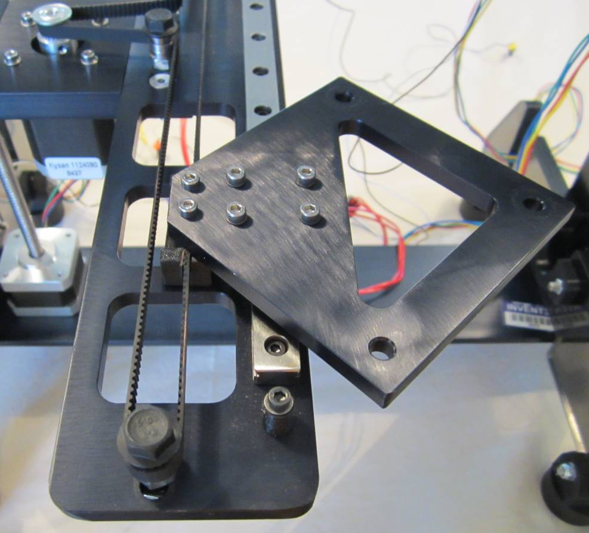
Insert screws through diamond plate and into belt clamp.

- Attach the filament drive to the extruder motor.

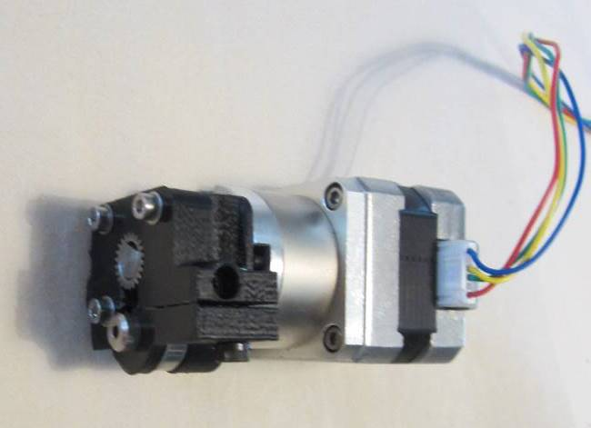
Orient filament drive with filament hole on same side as motor wire. Insert screws with washers and tighten.

- Place the extruder motor onto the extruder bottom. Secure the extruder top over the extruder motor using the two silver thumbscrews found in the x-axis box.

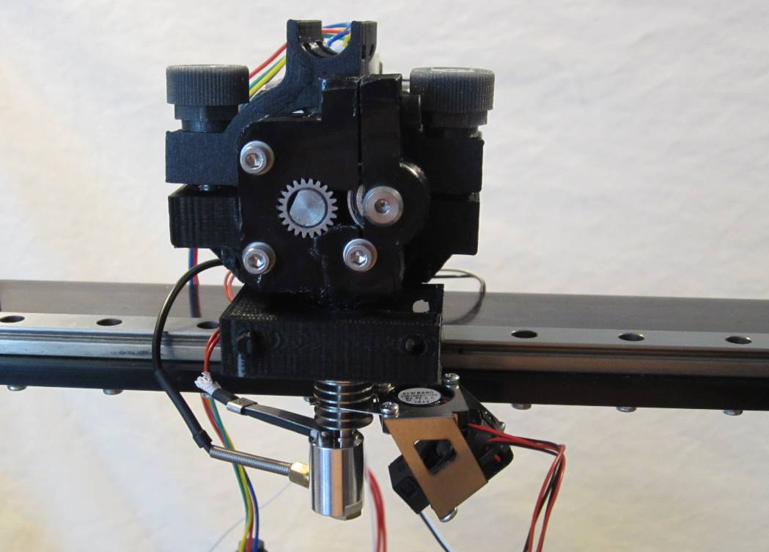
Cable tray on extruder top should point toward rear of printer.

- Attach the HOT! sign using the long black thumbscrew found in the x-axis box.

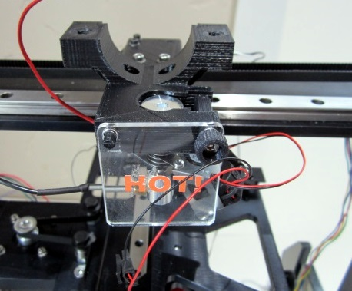
Insert thumbscrew through HOT! sign and extruder bottom and tighten.
One hole on HOT! sign should be placed on peg at front of extruder bottom.

- Remove the three red thumbscrews and wave springs from the print board plate.

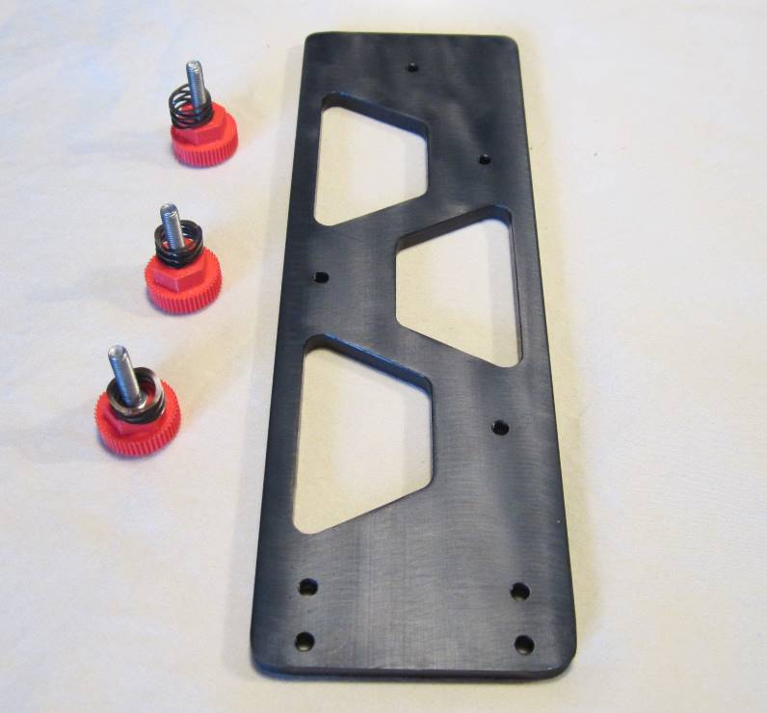
Print board plate with red thumbscrews and springs removed.

- Attach the rear board clamps to the print board plate so that the screws are hand tight. Attach the front board clamp using the blue thumbscrew.

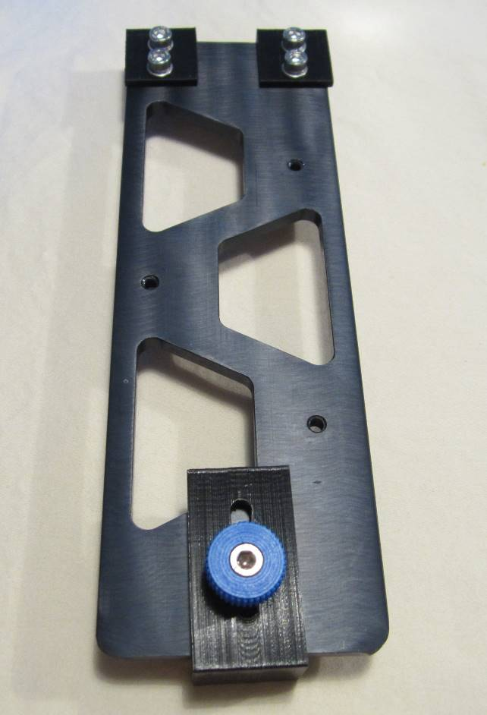
Ensure side with single hole is on your left with rear clamps away from you.
Insert screws with washers through rear clamps and into print board plate and partially tighten.
Insert thumbscrew through front clamp and into print board plate.

- Slide the print board into the rear clamps on the print board plate until the print board is completely seated into the rear clamps. Slide the front clamp into the notch on the front of the print board and tighten. Tighten screws in rear clamps to lock clamps into place. Loosen the blue thumbscrew and remove the print board.

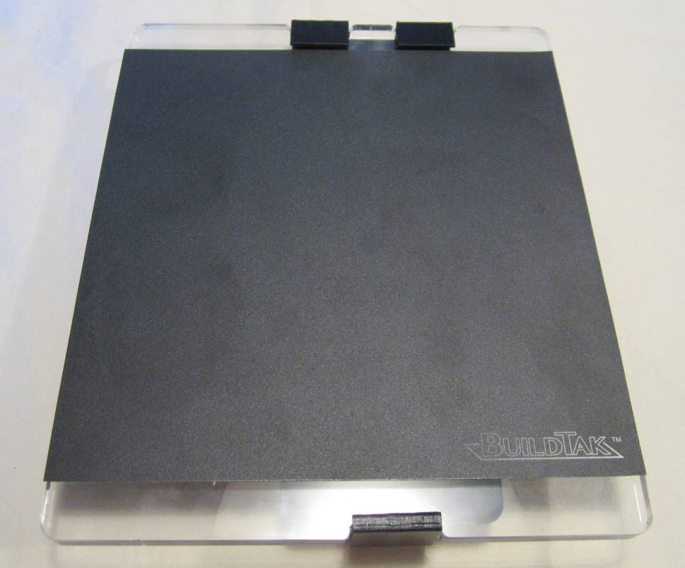
(2) Push front clamp so it sits flush in the cutout on the front of print board and tighten.
(1) Ensure print board sits completely flush with rear board clamps prior to tightening front clamp.
(3) Tighten rear clamps after tightening front clamp to ensure print board sits snugly in clamps.

- Place the print board spacer onto the diamond plate and align the three holes. Insert the three wave springs into the print board spacer.

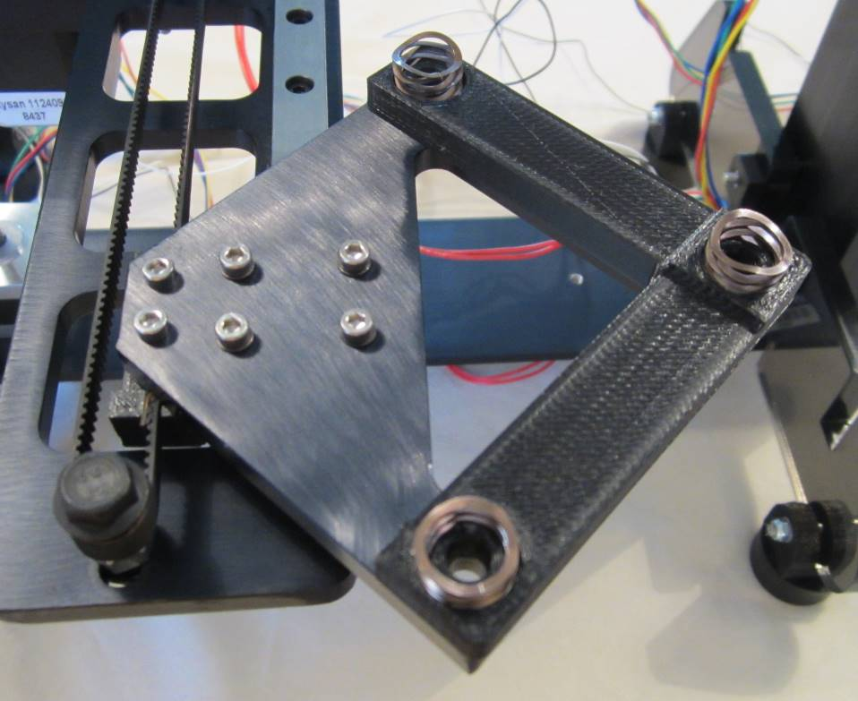
Ensure springs are completely seated in cutouts on top of print board spacer.

- Place the print board plate over the three wave springs. Insert the right-most red thumb screw and tighten halfway. Insert the remaining thumbscrews and tighten. Ensure that springs remain seated in the print board spacer. Tighten all thumb screws completely.

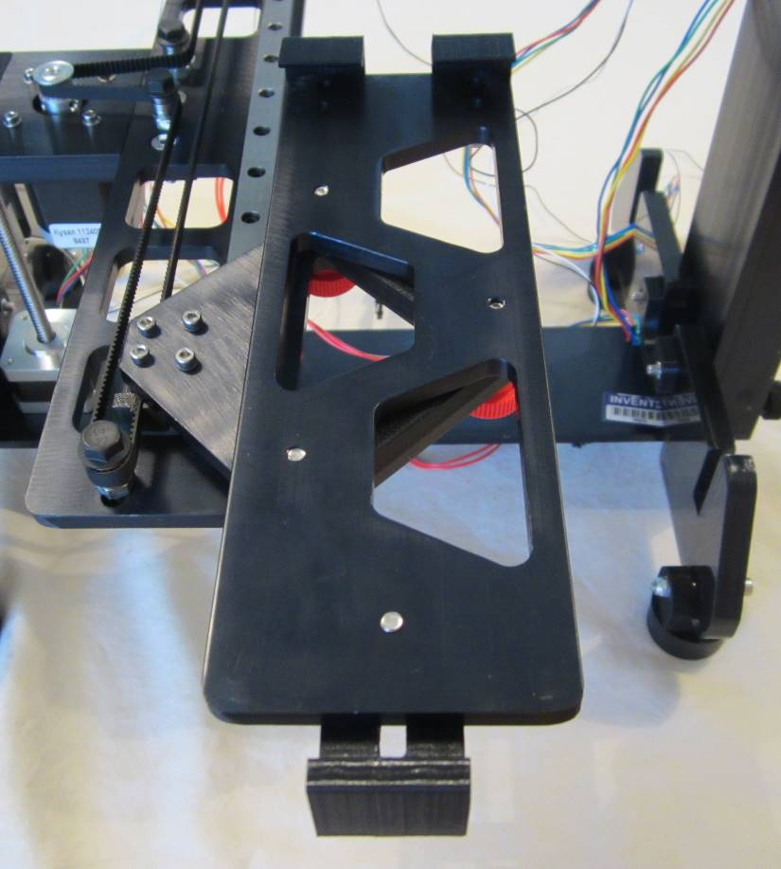
When completely tightened, left thumbscrews should be flush with print board plate and right thumbscrew should be almost flush.
Place pressure on print board plate to compress springs and allow thumbscrews to catch in threaded holes.
Insert thumbscrews into bottom of diamond plate, through spacer and springs, and into print board plate.

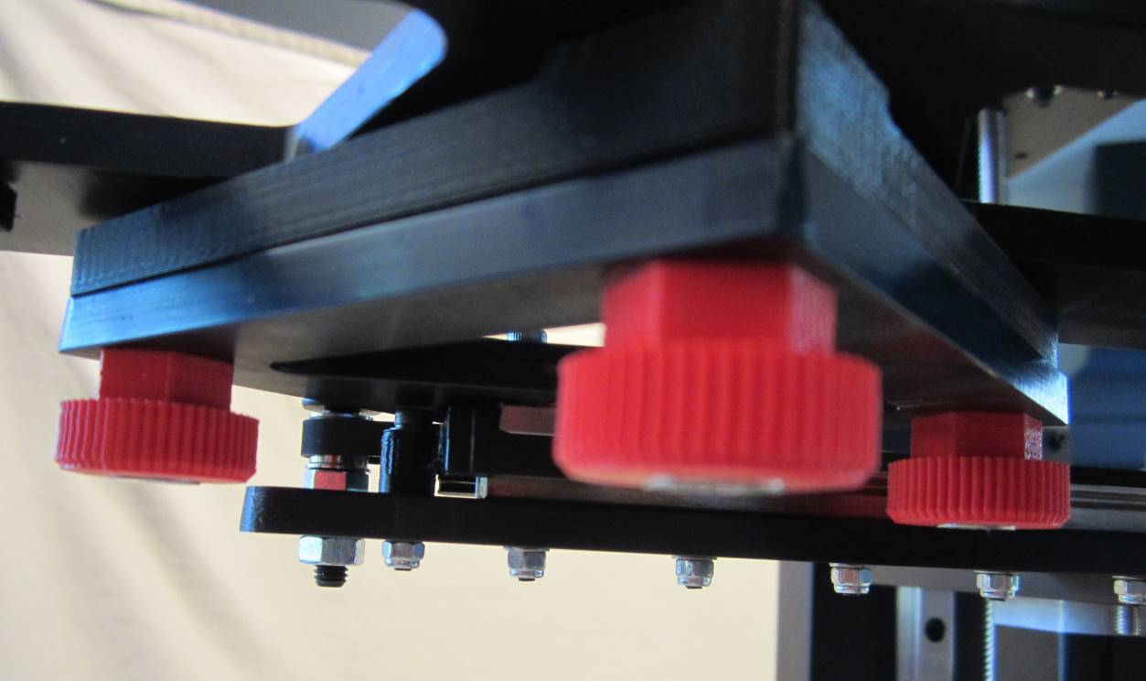
Tighten thumbscrews completely. If tips of left screws extend past top of print board plate, loosen screws until tips are flush with top of plate.
- Replace the print board onto the print board plate by inserting it completely into the rear clamps and tightening the front clamp. Follow the print board leveling procedures to level the print board.
Board Leveling Procedures
The board’s level is determined by three red print board leveling screws (thumb screws) below the board and one black Z-axis limit switch end stop screw (on the top, at the back left, smaller black screw). The black Z-axis limit switch end stop screw handles large calibration changes while the red leveling screws handle fine adjustments. You are calibrating the print head to be two print layers away from the board (approximately 0.2 mm) which is sufficiently measured by using a normal business card.
NOTE: Be safe – only level the print board when the hot end is cold. Board leveling should never be performed with a hot “hot end” as it can permanently damage the print bed.

Z-axis end stop
z
Z-axis lock
Red thumb screws
Z-axis knob

Plastic mount

Hot end
Z-axis limit switch
Gap
Print board

Print board plate

Diamond plate
Wave spring

Three points determine a plane. The object of board leveling is to use the three red thumbscrews to iteratively adjust the print bed plane so that the hot end is always the same distance from the print bed. The board leveling procedure is described in detail below:
- Always check to assure that the tip of the hot end is clean and remove any filament extruding from the tip. It may be necessary to heat the hot end to do this and then allow it to cool down.

- Turn the Z-axis end stop counter clockwise until the end of the screw is just visible and protruding from the plastic mount.

- Remove the print bed.

- Visually locate the ends of the red thumb screws in the diamond plate.

- Take turns tightening the red thumb screws until the ends of the thumbscrews are at the level of the top surface of the print board plate. If they will not tighten this far, check the seating of the wave spring in the spacer.

- Loosen the red thumbscrews approximately one full turn. It may help to place a mark in the same location on each thumb screw in order to tell how far they have been loosened. Check to see that all ends are recessed approximately the same depth from the surface.

- Replace and secure the print board.

- Move the print board and hot end so that the hot end is located directly over the center of the print board.

- Place a sheet of paper on the print board.

- Using the Z-axis knob, lift the print board until the paper is just slightly trapped by the hot end. The paper should be moveable with only slight resistance.

- Tighten the Z-axis yellow thumb screw to lock the print bed in place.

- Determine whether the front edge or back edge of the print board is the low side and slide the printer board so that the hot end is located approximately 1” in from the low edge of the bed.

- Loosen the corresponding front or rear red thumb screw to raise the print bed until it just traps the paper.

- Slide the print bed to 1” in from the opposite edge and adjust the corresponding red thumbscrew to trap the paper between the bed and the hot end. Recheck the gap at the opposite end. Repeat this process until the board is level front to back.

- Now return the hot end to the center of the print bed and determine whether the right or left side of the print bed is low.

- Move the hot end over the low side of the bed and adjust the red thumb screw on the right side until it just traps the paper between the bed and the hot end. Note that this will automatically lower the opposite side since there is only one thumbscrew in the X-axis.

- Repeat this process on the opposite side. Continue adjustments sliding the hot end side to side until the board is level in the X-axis.

- Leveling the board is an iterative process, so go back and recheck the locations previously leveled.

- Continue moving the bed and the hot end to various locations on the print bed and level using the appropriate red thumbscrew.

- This is not an exact science so the leveling does not have to be perfect. The first print layer will compensate for some degree of variation. However, the larger the surface area of the part to be printed, the more important it is that the board be level to prevent warping of the printed part.

- When the bed is level, release the yellow thumbscrew lock and lower the bed about an inch and remove the paper.

- Insert the z-axis end stop into the top plate and follow procedures to set the hot end gap.

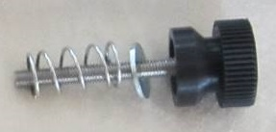
Z-axis end stop is comprised of three components: thumbscrew, washer and spring.

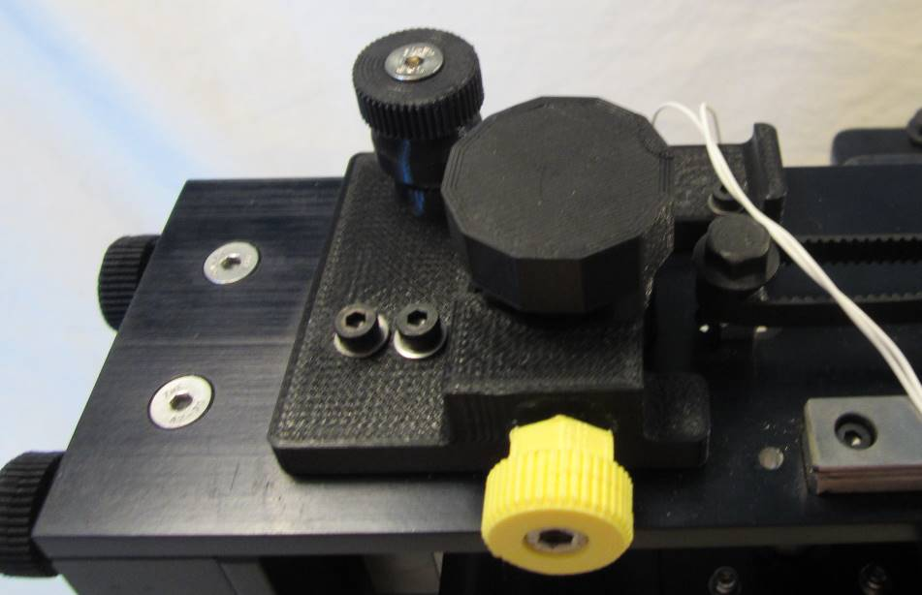
Insert spring in circular cutout and ensure it seated flush with bottom. Tighten z-axis end stop thumbscrew on top of spring.

Setting the Hot End Gap Procedures

Once the bed has been leveled, the final step is to set the gap between the hot end and the print bed. The proper gap setting is essential to obtaining a quality printed part that can be removed from the bed with minimal force. If the printed part is very difficult to remove, the gap is too small; if it warps or comes loose during printing or the first layer does not have a smooth appearance, the gap is too large.

The Z-axis end-stop determines how high the board will raise before the Z-axis limit switch is engaged. The object of setting the gap is to adjust the end-stop so that the print bed will be raised to within .015” of the hot end, or about a distance equal to the thickness of most business cards.

- To set the gap, align the hot end with the center of the print bed. Place a standard business card in the center of the print bed.
- Using the Z-axis knob, raise the print bed until it just traps the business card between the hot end and the bed. The card should move with some slight friction. Be careful not to press on the print bed when testing the movement of the business card.

- When the proper gap has been determined, lock the bed in place with the yellow thumbscrew.

- Lower the z-axis end-stop by turning it clockwise. Lower the end stop until you will hear a “click” as the limit switch engages. This step may be repeated to ensure engagement.

- Release the yellow thumbscrew and lower the board at least an inch. The gap is now set.

- The gap setting can be verified by going to “prepare” on the LCD screen and pushing in the LCD knob. On the menu find “go to home” and press the knob again.

- This will take the hot end to 0,0,0 location. Engage the yellow thumbscrew to lock the bed in place. Find “disable stepper motors” on the LCD screen and press the knob. This will free up the bed and the hot end so that they can be moved.

- Locate the hot end over the center of the bed and test the gap with the business card. If the gap is not proper distance, loosen the yellow thumb screw and Z-axis end stop. Using the Z-axis knob adjust the height of the bed to the proper gap setting. Lock the bed in place with the yellow thumb screw and adjust the Z-axis end stop to just engage the Z-axis limit switch.

- Unlock the yellow thumbscrew and lower the board. Recheck the gap using the LCD steps as above.

- Attach the RAMBo board with using the two orange thumbscrews.

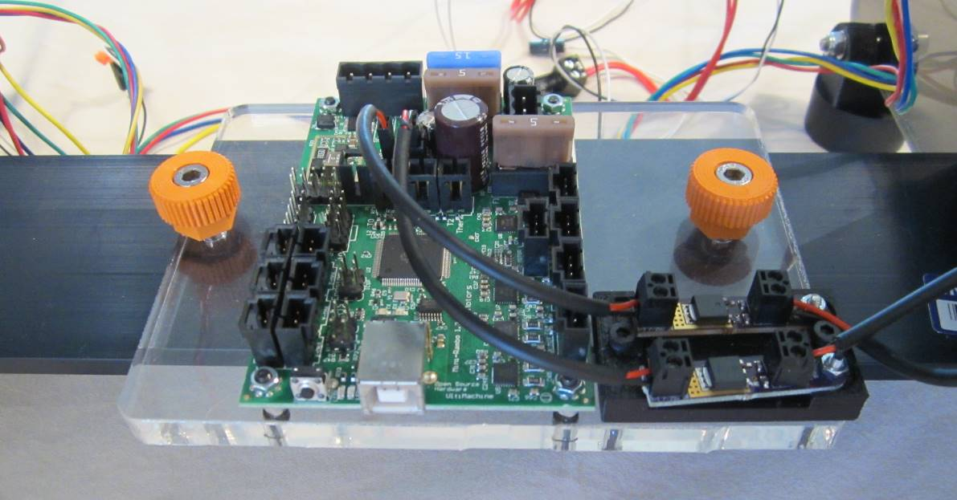
USB port should be at front of printer.
Thumbscrew locations.

- Untangle all wires. Remove the right channel. Pass the fan wires from the RAMBo board, through the hole in the right side frame, and connect to the hot end fans.

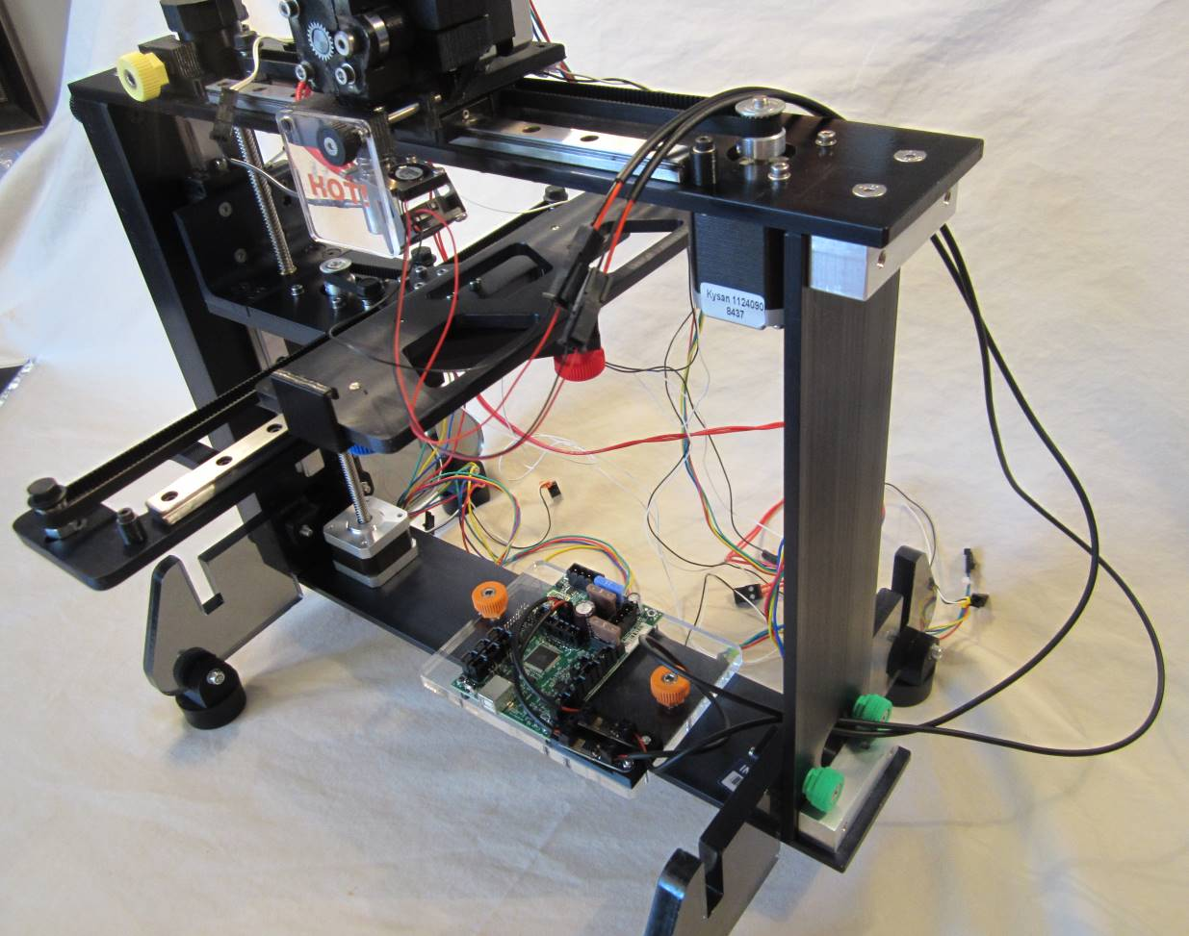
Connect fan wires to fans at quick disconnects.
Pass fan wires through hole in right side frame.

Pass right side wires (hot end wire, thermistor wire, limit switch wire, extruder motor wire, x-axis motor) through the hole in the right side frame.

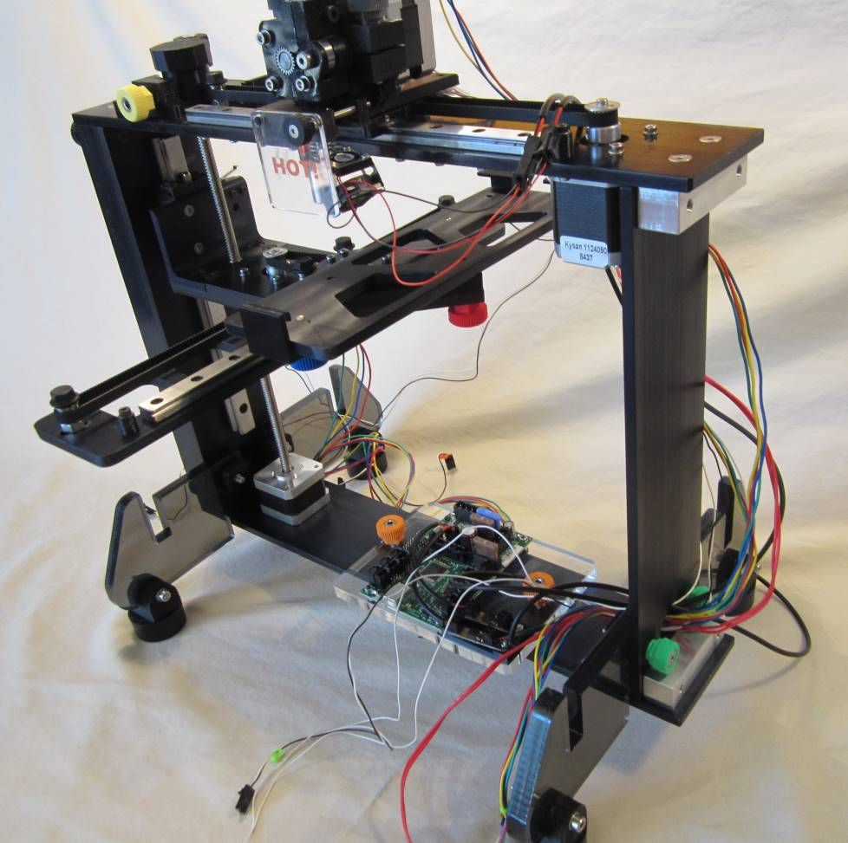
Pass hot end, thermistor, x-axis limit switch, and x-axis motor wires through hole in right side frame.

Group hot end wires together and insert into the longer wire sleeve just past the quick disconnects until approximately 3” of wire are inserted. Pass zip ties through slots in extruder top and tighten to fasten wire sleeve in place. Insert the extruder motor wire and x-axis limit switch wire into the wire sleeve until approximately 3” of wire are inserted. Place zip tie at point where extruder motor and x-axis limit switch wires enter the wire sleeve. Insert all wires for the remaining distance of the sleeve.

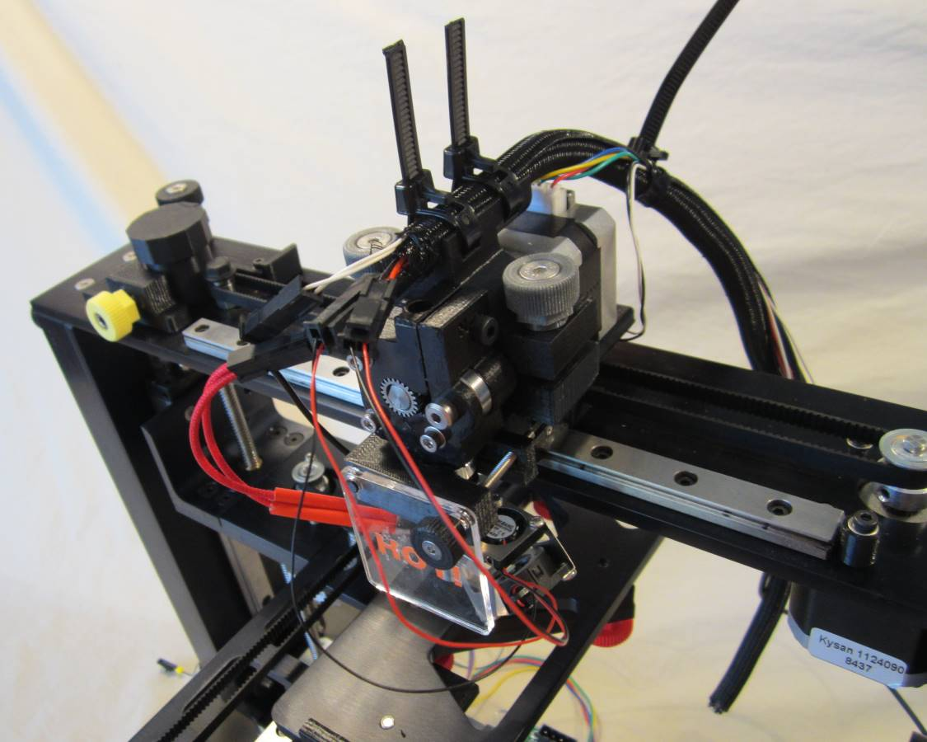
Extruder motor and x-axis limit switch enter sleeve together. Place zip tie just below.
Hot end, thermistor, and fan wires enter sleeve together. End of wire sleeve in front of first zip tie.

Insert the x-axis motor wire for the last 1” of the sleeve and secure with a zip tie.

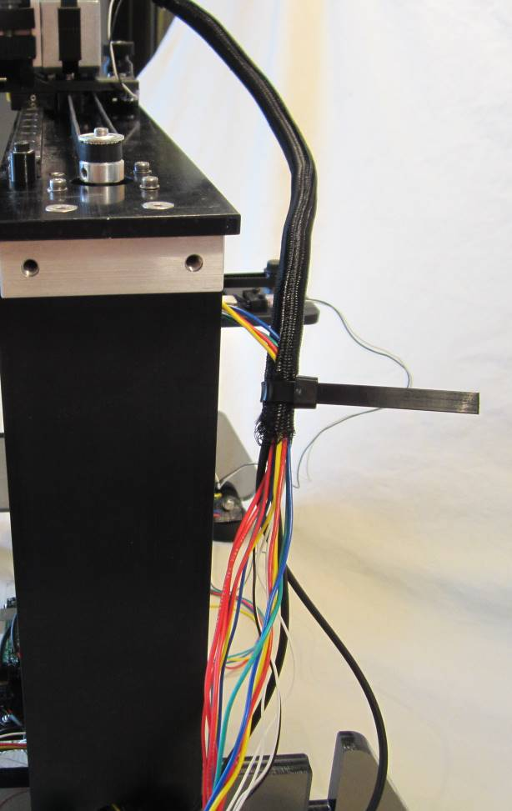
X-axis motor enters sleeve approx. 1” above end. Zip tie placed just below.

Plug all wires into appropriate places on the RAMBo board. Place a zip tie around the right side wires near the RAMBo board.

Thermistor
X-axis limit switch
Hot end
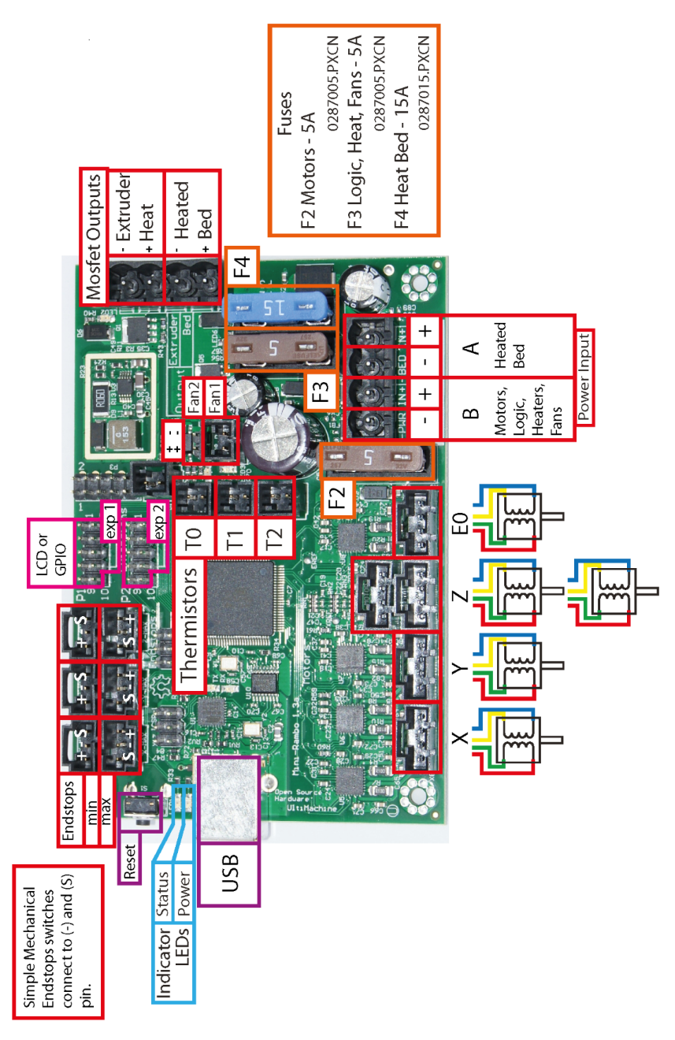
X-axis motor
Extruder motor

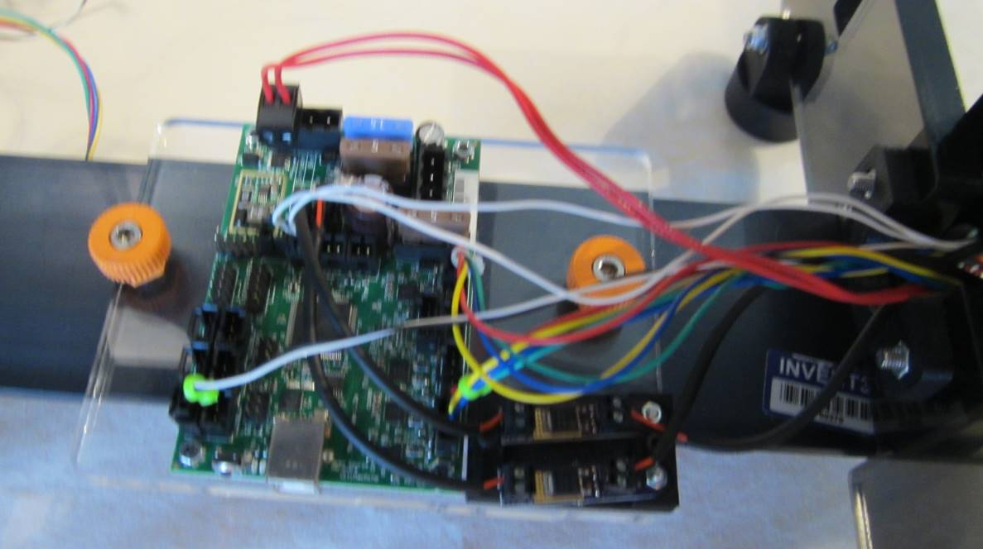
Group wires and place zip tie at this location.
Connect all right side wires to RAMBo board.
Replace the right side channel ensuring that the wires pass through the notch at the top.

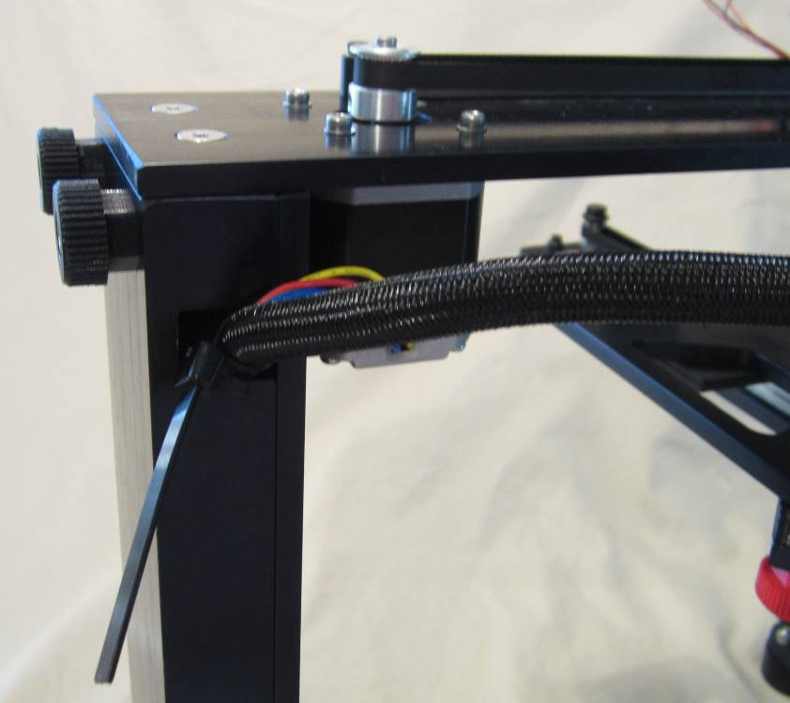
Wire sleeve passes through notch on right side channel. Zip tie sits just outside of channel.

- Remove left side channel. Pass left side wires (y-axis motor, y-axis limit switch, z-axis limit switch) through the hole in the left side frame.

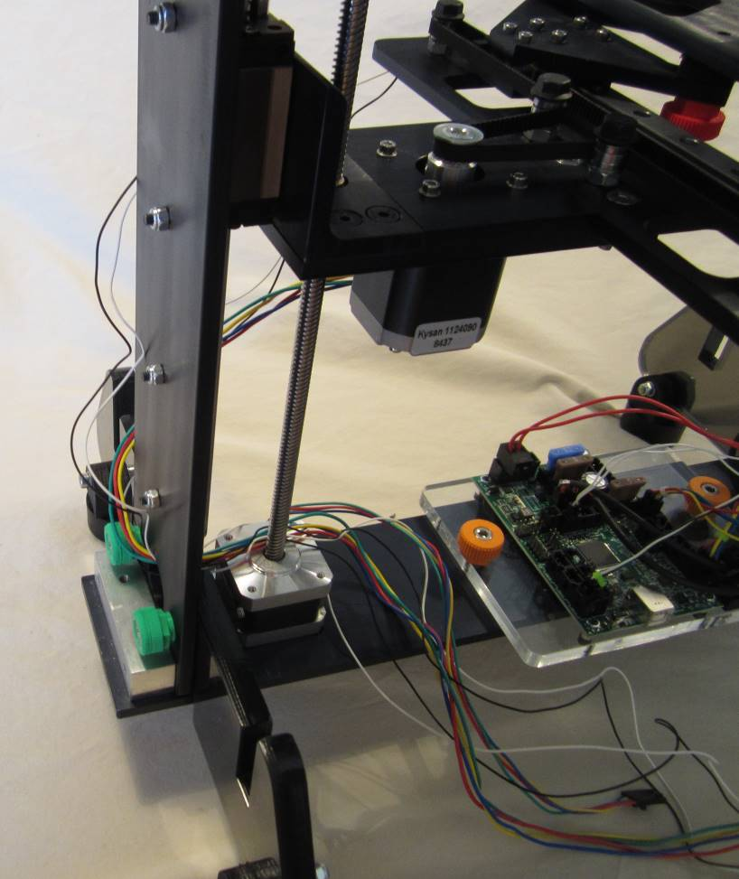
Y-axis motor, y-axis limit switch, and z-axis limit switch wires pass through hole in left side frame.

Insert the three wires into the shorter wire sleeve and place a zip tie on each end of the sleeve.

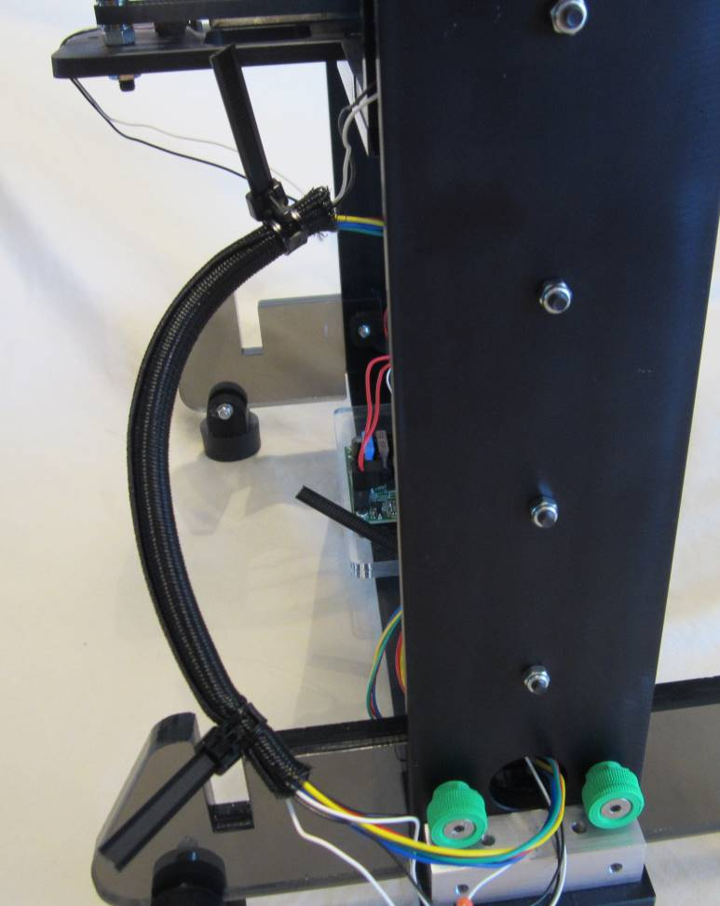
Zip tie placed at end of sleeve.
Y-axis motor, y-axis limit switch, and z-axis limit switch wires enter sleeve together. Slide sleeve up to point where tension just placed on wires. Zip tie placed at top of sleeve.

Plug all left side wires, including the z-axis motor wire, into the appropriate locations on the RAMBo board. Neatly arrange the left side wires and place a zip tie around them near where they connect to the RAMBo board. Pull excess wire though the frame on the left side and slide the wires in the slot between the z-axis motor and left frame.
Y-axis limit switch
Z-axis limit switch

Z-axis motor
Y-axis motor
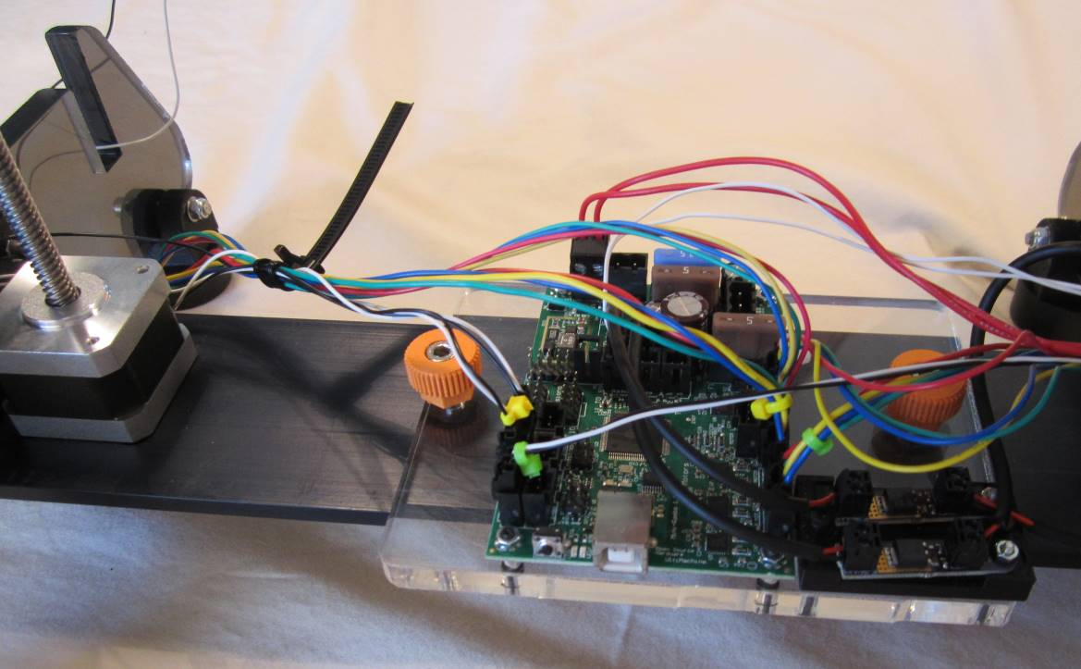
Group y-axis motor, y-axis limit switch, z-axis limit switch, and z-axis motor wires and place zip tie here.
Connect y-axis motor, y-axis limit switch, z-axis limit switch, and z-axis motor wires to RAMBo board.
- Attach the spool holder to the left side channel using the white thumbscrews. Replace the left side channel and attach filament guide on top at same time. Ensure that wires cleanly pass through the notch in the channel without pinching. The zip ties should be on the outside.

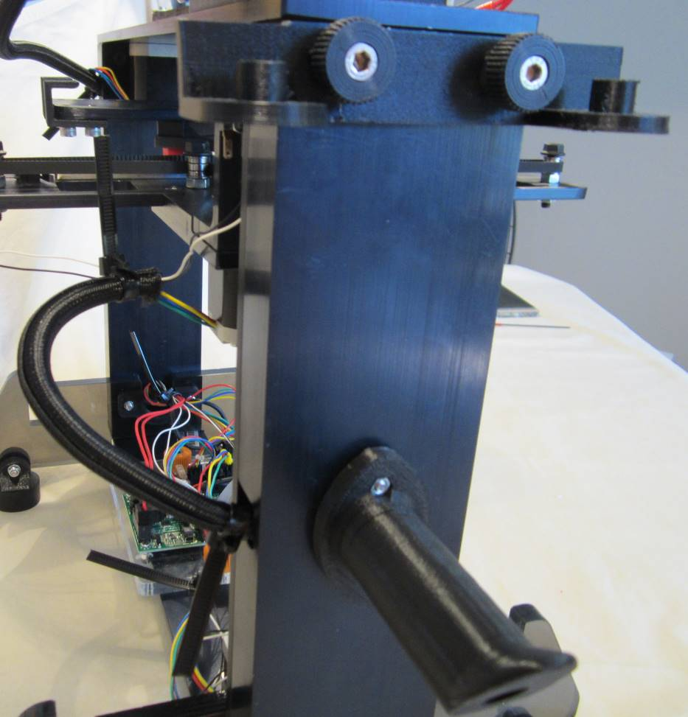
White thumbscrews inserted from inside channel and into spool holder. Tip of spool holder pointed up.
Insert thumbscrews through filament guide and right channel and into connector block.

- Plug the LCD display into the RAMBo board.
LCD Screen
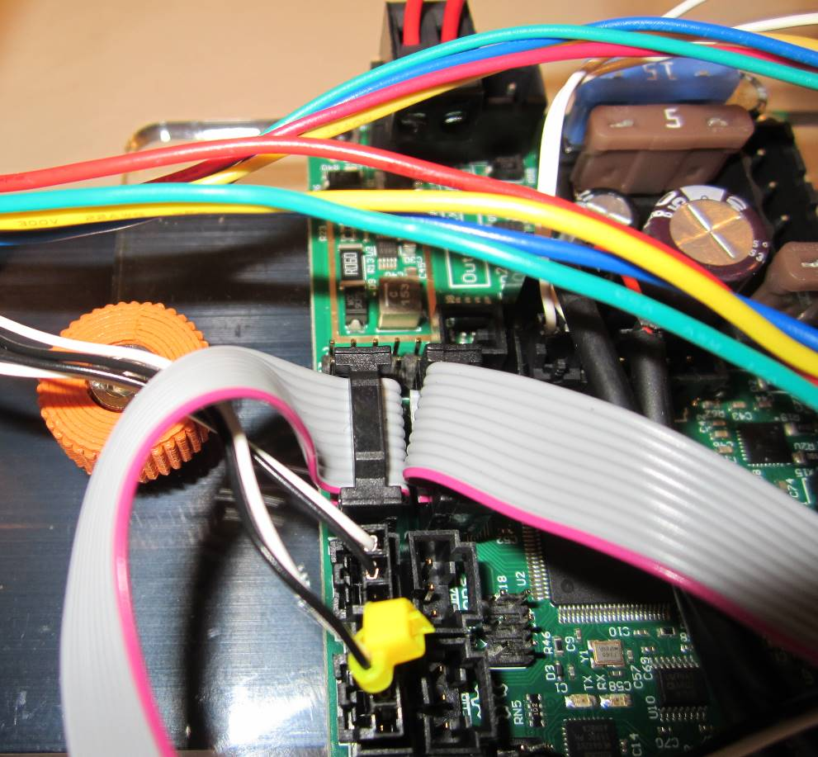
LCD cables plug into RAMBo board with red strip closest to front of printer.
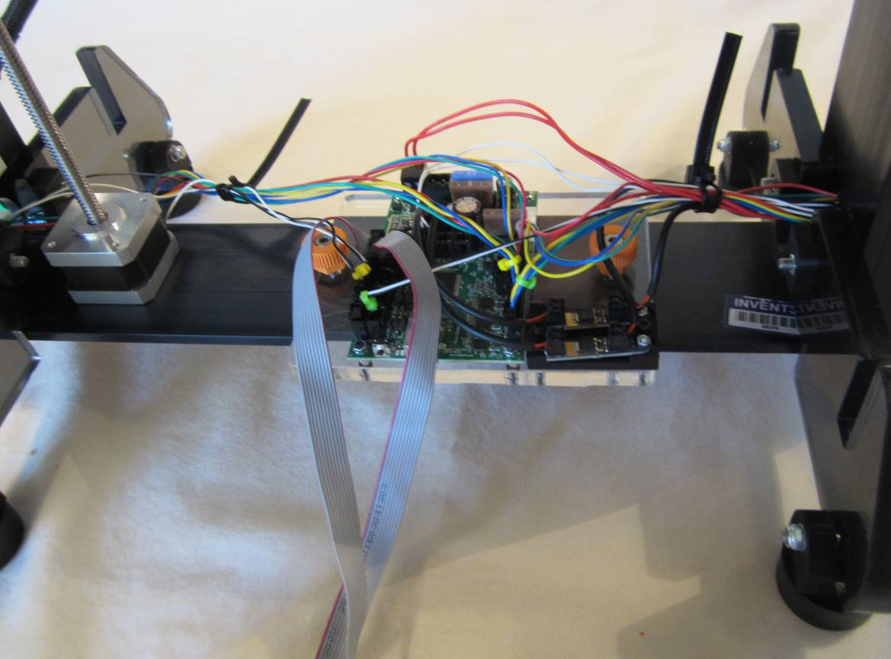
LCD cables should cross once from back of LCD screen to RAMBo board.

- Attach the power plug breakout board to the rear cover. Insert the rear cover into the slots on the printer legs. Plug the power plug breakout board wire into the RAMBo board.

Power supply
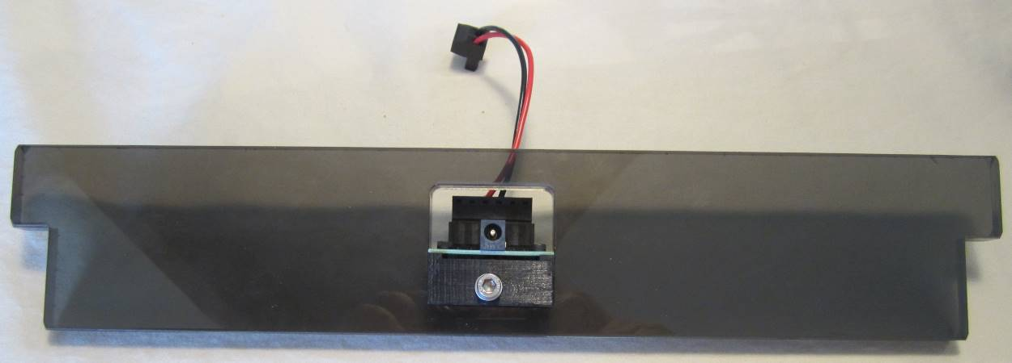
Push power plug breakout board clip onto bottom of cutout in rear cover and tighten set screw.

- Place the front cover into the slots on the printer legs. Place the LCD display into the slots on the front cover.

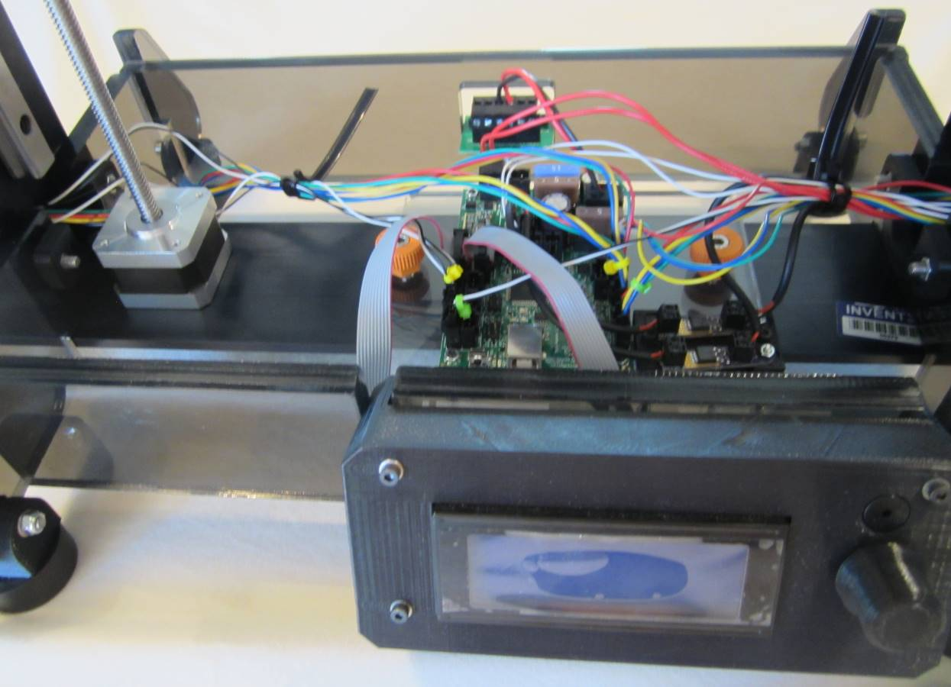
LCD housing seated into slots on front cover. LCD wires pass beneath front cover.

- Place the print board into the print board bed and lock into place. (Refer to Step 40 photo).

- Place top cover onto the printer legs.

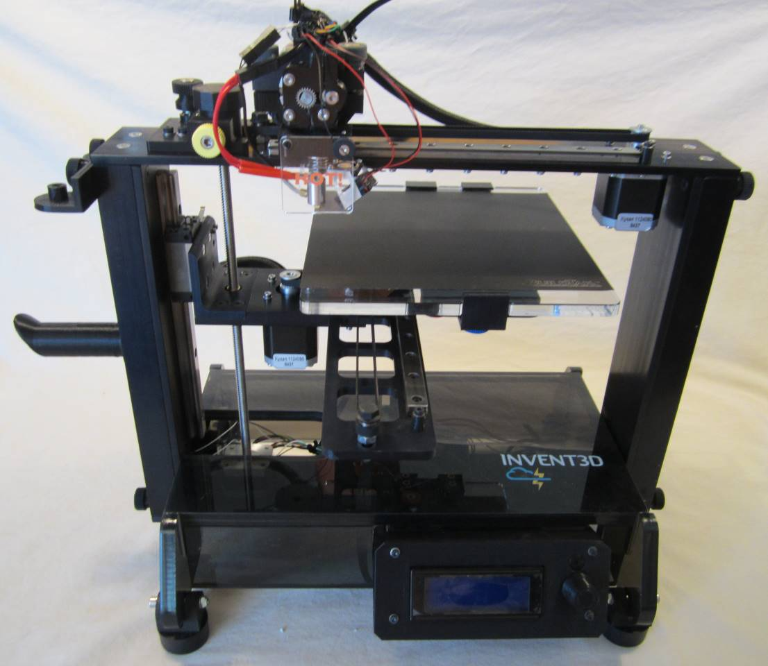
Replace print board (Step 39).
Top cover rests flat on front and rear covers and printer legs.

- Re-check board level by following the procedure presented in Step 30. Re-check the hot end gap by following the procedures presented in Step 31. Perform the following testing procedures to ensure that the printer is functioning properly.

Printer Testing Procedures
It is important to test all components of printer prior to use. This section provides direction to verify that all wires are connected properly, motors are wired properly, and end stop switches are in the correct position. The printer must be plugged in prior to beginning testing.
Checking motors

- Press LCD button; menu will display. Options are viewed by using button for scrolling and pressing LCD button to “select” item highlighted

- Go to “Prepare” and select; menu will display.

- Go to “Move Axis” and select; menu will display.

- Go to “1 mm” (moves stepper motor by 1 mm) and select; menu will display.

- Go to “X axis” and select.

- Rotate the LCD knob slowly. Rotating clockwise, head assembly moves away from the X-axis limit switch. Rotating counter clockwise, head assembly moves toward the X-axis limit switch. This confirms that motor has been wired properly.

- Repeat steps 1) through 6) with Y-axis and Z-axis.

Checking Auto Home

- Press LCD button; menu will display.

- Go to “Prepare” and select; menu will display.

- Go to “Auto Home” and select.

- Head assembly will move to 0,0,0 position.
- If you hear any noise, trouble shoot. Causes may include: belts may not be aligned, yellow thumbscrew not released, may need to apply grease, end stop switches are not functioning properly, etc.
Always disable motors after testing Auto Home. Otherwise, they will be in a frozen state.
- Press LCD button; menu will display.

- Go to “Prepare” and select; menu will display.

- Go to “Disable Steppers” and select.

Hot End

- Press LCD button; menu will display.

- Go to “Prepare” and select; menu will display.

- Go to “Heat PLA” and select.

- Temperature will start to increase (it is set at 225oC for PLA)

- The fans should come on when the temperature reaches about 50oC (carefully listen to verify both fans are on).

Filament Feed/Extruder

Please note that you cannot test Filament Feed or feed filament when hot end is cold.

Side of spool with cutout is closest to printer so that spool rests flat against printer.
Pass filament through filament guide on same side that it leaves spool.

- Press LCD button; menu will display.

- Go to “Prepare” and select; menu will display.

- Go to “Move Axis” and select; menu will display.

- Go to “1 mm” and select; menu will display.

- Go to “Extruder” and select; menu will display.

- Feed filament into the small hole above the filament feed gear.

- Hold the filament with one hand, and turn the knob on LCD clockwise.
Filament should be drawn through the gear into the hot end. If this does not happen, it is not aligned.
Troubleshooting Tips for Filament Feeding

- Loosen the silver thumbscrews to adjust motor assembly.

- Manually align the filament so that it is aligned with the gear on the feed.

- Extrude some filament by turning the LCD knob clockwise to verify working correctly.

Do not leave the filament in the feed if printer will be idle for a week or longer as the filament will deteriorate, becoming more heat resistant which leads to clogging feed assembly and nozzle.

Cooldown

Please do not leave the hot end heated for long periods when not in use.

- Press LCD button; menu will display.

- Go to “Prepare” and select; menu will display.

- Go to “Cool Down” and select; menu will display.

- Temperature will go down.

- Fans will turn off at 50oC and below.

When temperature is below 50ºC and if printer will be idle, unplug the power source.

Test Print

A test file has been preloaded on the SD card. Print test file to check print. Do NOT print any other file until the test file is accurately printed.
- If not already in LCD, insert SD card fully in the left side of LCD.

- Press LCD button; menu will display.

- Go to “Print” and select.

- Temperature will begin to rise to set point shown on LCD.

- Print head will move to right front of print board and extrude a small amount of filament.

- Printing of test part will initiate.

- If part does not print, refer to Troubleshooting Guide in Operating Instructions.

- Assess quality of printed part. If it is not good quality, refer to Troubleshooting Guide in Operating Instructions.

- Understanding operation and maintenance is key to successful printing. It is very important to read and understand the INVENT3D Operating Instructions and Troubleshooting Guide and view the videos below. Also visit www.inventorcloud.net to check for new information and documentation.

The slicer program must be downloaded from www.inventorcloud.net . Every printer has unique settings in the slicing program. These settings are NOT interchangeable. Use of settings NOT specific to the INVENT3D Printer will cause it to print poorly and may damage the printer.

INVENT3D Printer Videos

Videos are available on YouTube and INVENTORcloud website:

- Installing Slic3r: https://youtu.be/-kWy8JPh2IQ
- INVENT3D – Keys to Success: https://youtu.be/4-TP87f_Dtk
- Changing Filament: https://youtu.be/GkhGFjlLo9Y
- Part Removal: https://youtu.be/YJ2lwoVA1l4
- Print Board Leveling: https://youtu.be/t5xmp9knYew
- Routine Maintenance: https://youtu.be/GVPg4gXYw9w
- Z Axis Calibration: https://youtu.be/jwzYRii9fM0

Applying BuildTak

- BuildTak is an adhesive for the print board that allows for easy removal of printed items. There are other materials that can be used (ie: painter’s tape, hairspray, etc) but BuildTak provides ease of use. Parts must be removed carefully to remove damaging the BuildTak sheet.

- Loosen the blue thumbscrew and back out the front print board clamp.

- Slide print board out from the rear board clamps.

- Remove old BuildTak and if necessary, clean board if cloudy layer of adhesive remains.

- Remove the plastic covering over the back of new BuildTak sheet to expose the adhesive.

- Center over board, start by laying one side down and smoothing the surface as the sheet is laid down. Apply slowly and avoid bubbles. If necessary, pull section back up, press out bubbles and smoothly lay it down.

- Insert the print board back into the rear board clamps. Slide the front board clamp forward to lock the print board in place and lock by turning the blue thumbscrew clockwise.

