**IMPORTANT NOTICE**

**INVENT3D PRINTER OWNERS, OPERATORS AND LEASEHOLDERS**

Do not operate INVENT3D Printer unattended or without oversight for any period of time.

Recently, an INVENT3D Printer caught fire which was unattended for an extended period of time. While this is the only reported incident that Applied Systems & Technology Transfer, LLC (AST2) is aware of, it is important for INVENT3D Printer owners, operators and leaseholders to exercise care and caution.

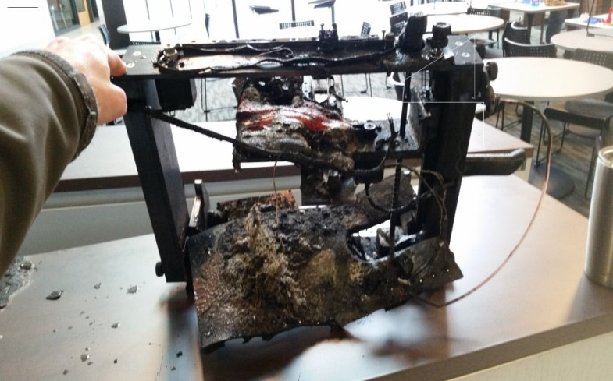We have little information on the cause of the incident. The only information that we are aware of at this point is that the printer was in the middle of a 20-hr print job, and completed about 12 hours of printing.

Some printer components are made of flammable materials, and in the unlikely event of a fire, would burn. Furthermore, smoke or fire may cause fire suppression activation and additional damage to facilities.

When not in use, it is best practice to power off INVENT3D Printer.

AST2 is presently investigating the cause of the fire. AST2 will identify appropriate remedy.

AST2 has manufactured and delivered hundreds of INVENT3D Printers without incident. Be assured that AST2 is committed to the highest quality and safety standards.

Please contact Gug Sresty at (626)422-3534 or [gug.sresty@ast2.net](mailto:gug.sresty@ast2.net) or Nick Mazurek at (330)766-0227 or [nick.mazurek@ast2.net](mailto:nick.mazurek@ast2.net) if you have any questions.

**NOTICE TO INVENTORcloud Program Schools and Advanced Methods in Innovation customers:**

AST2 is the manufacturer of INVENT3D Printer. Please contact AST2 if you have any questions or concerns.