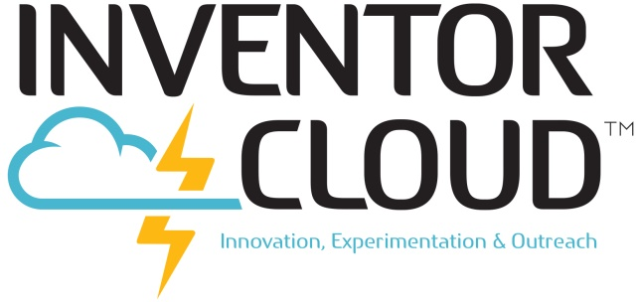
For Columbiana County OH, see below.

CONTACT INFORMATION (email and phone/text)
Julie Michael Smith, Executive Director, Advanced Methods in Innovation/INVENTORcloud
jmsmith@inventorcloud.net and 330-727-6292
Responsibilities: Moodle, curriculum, field trips, ordering PLA and any other questions

Craig Richards, Technology Director: craig.richards@ast2.net and 330-942-1829
Responsibilities: STORM:Box and Moodle (including creating accounts and forming teams); can assist with technical questions

Francis Owusu-Dompreh, INVENTORcloud Lab Manager: Francis.Owusu-Dompreh@ast2.net and
330-942-7781
Responsibilities: Setting up and facilitating sessions using STORM:Box, 123D instruction, review of files, 3D printing and other use of INVENTORcloud equipment

Joe Jeswald, INVENTORcloud Educational Consultant: joseph.jeswald@att.net and 330-501-2332
Responsibilities: Curriculum, instructional support and professional development

Bill Scott, INVENT3D Program Manager, bill.scott@ast2net and 626-590-6430
Responsibilities: Secondary point of contact for INVENTORcloud Operations and operation of INVENT3D Printer

PROJECT INSIPRE ONLY – COLUMBIANA COUNTY, OH
Matt Peters, Project Inspire INVENTORcloud Lab Manager: mpeters@ccesc.k12.oh.us
330-424-9561 x308
Responsibilities: Setting up and facilitating sessions using STORM:Box, 123D instruction, review of files, 3D printing and other use of INVENTORcloud equipment

Steve Stewart, ESC Consultant sstewart@ccesc.k12.oh.us and 330-424-9591 x182
Responsibilities: Primary point of contact for Project Inspire Project – can facilitate any questions regarding INVENTORcloud

